A

Project Report

On

**“TRADING MANAGEMENT”**

**“SYSTEM”**

Designed &Developed

By

**SUPRIYA DATTATRAY SADAMBAR**

Submitted in partial fulfillment of academic project

Bachelor of Science (Computer Science)

[**University of Mumbai**]

**YASHWANTRAO CHAVAN COLLEGE,**

**SECTOR-15,KOPARKHAIRANE,VASHI,**

**NAVI MUMBAI - 400 709.**

Academic Year 2014-2015



# YASHWANTRAO CHAVAN COLLEGE,

# SECTOR - 15,KOPARKHAIRANE,VASHI.

NAVI MUMBAI – 400 709.

# A

# PROJECT

# REPORT ON

**TRADING MANAGEMENT**

**SYSTEM**

By

**SUPRIYA DATTATRAY SADAMBAR**

Under the Guidance Of

**Ms. VAISHALI DASARWAR**

Submitted to

[**University of Mumbai**]

Academic Year 2014-2015

**YASHWANTRAO CHAVAN COLLEGE OF ARTS,SCIENCE AND COMMERCE**

**KOPERKHAIRANE,NAVI MUMBAI**



**CERTIFICATE**

**This is to certify that SUPRIYA DATTATRAY SADAMBAR**

**has satisfactorily completed the project work on Medical Store Management**

**System**

**For partial fulfillment of the 3 years full time course Bachelor of Computer Science of the University of Mumbai for the year 2014-2015.**

**Place:**

**Date:**

**Internal Project Guide Head of Department**

**External Examiner Principal**

**ACKNOWLEDGMENT**

It is always a difficult task to acknowledge all those who helped me a lot doing this project. Nevertheless I have made an attempt through this report to express my deepest gratitude to all those who have contributed in making of this project either directly or indirectly.

It gives me great pleasure to present my project on **“TRADING Management System”.** This is my first milestone in **Bsc CS**.

I would like to express my sincere thanks to my project guide **VAISHALI DASARWAR**who helped me throughout the project.

Last but not the least I am also thankful to my Head Of Department head **VIDYA BHILAWADE** who encouraged me and gave me moral support during my project. I would like to thank all my teaching and non-teaching staff of Information technology faculty who helped me

in completion of my project.

|  |  |  |
| --- | --- | --- |
| **Sr.No** | **Contents** | **Page no** |
| **1.** | **Introduction** |  |
| **2.** | **Organization Overview**  **2.1 project** OBJECTIVE  **2.2 Existing system** 2.3 LIMITATIONS OF EXISTING SYSTEM **2.4 Proposed System**  **2.5 System Specification**  **2.5.1 Hardware Specification**  **2.5.2 Software Specification** |  |
| **3.** | **Feasibility Study**  **3.1 Operational Feasibility**  **3.2 Technical Feasibility**  **3.3 Economical Feasibility**  **3.4 Motivation Feasibility** |  |
| **4.** | **System Analysis**  **4.1 Event Table**  **4.2 Entity Relationship Diagram**  **4.3 Use-Case Diagram**  **4.4 Activity diagram**  **4.5 sequence diagram**  **4.6 Class Diagram**  **4.7 State-Transation diagram**  **4.8 component Diagram** |  |
|  |  |  |
| **7.** | **Screen Layout and Report Layout** |  |
| **8.** | **Coding** |  |
| **9.** | **Gantt Chart** |  |
| **10.** | **Validation** |  |
|  |  |  |
| **12.** | **Methodology Used For Testing** |  |
| **13.** | **Future Enhancement** |  |
| **14.** | **Conclusion** |  |
| **15.** | **Bibliography** |  |
| **16.** | **Webiliography** |  |

Preliminary Investigation

# 

# INTRODUCTION

This project is designed in vb.net along with SQL. This project basically deals with issues regarding selling of the trading products.

This system is a process that allows a customer to choose any of the product that they want.

It efficiently does functions like taking information from customer, retrieval of data for cancellation and conformation of purchased good.

This program is designed in such way that it uses vb.net as Front End which provides the user an Graphical User Interface to interact with the system and SQL (structured query language) as a Back End.

# 

**1. Organization Overview**

# OBJECTIVE

* The present existing system is manual and requires man power for maintaining data.
* The use of computer only for making reports by typing if it is needed.
* The dates are maintained in files and registers especially for maintain GR’s records.
* The process of manual management is very tedious and is expensive.
* The existing system is error prone as human beings are prone to errors.
* The new proposed system will make work easier, increase speed, all details generation within a single a mouse click and rest of the processes will be automated.

# EXISTING SYSTEM

* The existing system is based on manual procedures. All the above function are store manually in to the file registers. They have to maintain that record for long duration, but the maintaining all this records as manually is very difficult task.
* The present existing system of clerk is done manually, which is too lengthy and tedious. The present existing system consists of many jobs such as:-
* Issuing of the kepping records.
* Issuing the bill paying.
* Confirming the buy and selling.
* The present existing system is time consuming and sometimes it also last for two months. The system is not reliable as it deals with feature of many students. The system also puts burden on the clerk office to issue all reports on the fixed data can even make mistake in report while making in hurry.

## LIMITATIONS OF EXISTING SYSTEM

Since the present system is manual, due to this it has the following limitations.

* The work is done manually and there is only one person appointed to do the transaction work and keeping the record in the registers. This sometimes results in misplacement of certain records.
* To keep track of information is much more difficult.
* It is difficult to find a particular student records from the registers.
* It is very difficult to know how any information is given by particular students.
* Updating the registers about all the information takes a lot of time.

Due to these limitations, there is a need of a system which could solve all these problems.

# PROPOSED SYSTEM

* Searching of information of any particular type is easy and also faster.
* Reduces the time that is wasted in updating the file manually.
* Reduces data redundancy as once data is entered, it will be carried forward for any requirement, no need of re-entering the data.
* GUI based interactive screen are made easy to understand.
* Appropriate database tables are maintained to record and store validated information
* Facility to search a particular record implemented

# HARDWARE & SOFTWARE SPECIFICATION

## Hardware Specifications:

|  |  |
| --- | --- |
| Processor | Intel Pentium Dual Core |
| RAM | 4 GB |
| Cache Memory | 8MB |
| HDD | 500 MB |
| CPU Clock Speed | 2.10Ghz |

## Software Specification:

|  |  |
| --- | --- |
| Operating System | Windows 7 |
| Front End | Visual stdio 2008 |
| Back End | Sql server 2005 |

## Minimum Hardware Requirements:

|  |  |
| --- | --- |
| Processor | Intel Pentium IV or higher |
| RAM | 512MB |
| Space On Server | 200 MB |

## Minimum Software Requirements:

|  |  |
| --- | --- |
| OS | Windows XP or Higher |
| Browser | HTML5 Supported |
| Other | JRE 7 or higher |

**2. Feasibility Study**

**Feasibility Study**

All project are feasible, provide that unlimited resources and infinite time are available. However, in real world that can sound like a dream. Especially Computer based systems are likely to be bounded by limited recourse as well as time. Feasibility and risk analysis is related in many ways. If the risk is great then feasibility of producing quality software is reduced. During system engineering, we concentrated our attention in three primary area of interest.

## Operational Feasibility

* + - * + The New System can be beneficial only if satisfied the organization requirements in such a way that resources utilization and optimum outcome is justified new system not only be robust but should also to work simultaneously with other systems. Operational feasibility means that new system should not affect any existing system during the development phase or even in the implementation phase.
        + Efforts were made to optimize the human efforts in the data collection, storage, retrieval, security and presentation. The Management was always in touch with the latest development. The proposed system made best efforts in achieving necessary function and performance, as required by the user and keeping in mind some infrastructure constrains.

## Technical Feasibility

Developers of computer based system are optimists by nature. During an Evaluation of technical feasibility, a cynical, if not pessimistic attitude should prevail. Misjudgment at this stage can be disastrous. The technical issues that came up during the analysis were. All hardware supports required for the development of the System was preexisting With “Online Mobile Shop”. So, technically the development of the system was Feasible.

## Financial and Economic Feasibility

Among the most important issues in the feasibility study is ‘Cost Benefit Analysis’, an assessment of the economic justification for a computer-based system project. Cost of conducting system study and investigation is justified since the system development is in house. There is no extra cost of hardware, as it already exists enough.

# STAKEHOLDERS

Stakeholders are anyone who has an interested in the project. Project stakeholders are individual and organization that are actively involved in the project, or whose interests may be affected as a result of project execution or project completion. They may also exert influence over the project`s objectives and outcomes. The project management team must identify the stakeholder, determine their requirement and expectations and to the extent possible, manage their influence in relation to the requirement to ensure a successful project.

The following are examples of project stakeholders:

* **Project Developer**:  
  A project developer is one who develops software for customer. In my project I am the stakeholder i.e. project developer.
* **Project Customer**:  
  A project customer is one who pays for the developed software.
* **Project User Group**:  
  Project user group are those who use the software on daily basis for the project customer.
* **Project Tester**:  
  Project testers are those who test the software, in my project myself, my project guide and technical department are the fourth stakeholders i.e. project tester.

# GANTT CHART

A Gantt chart is a type of [bar chart](http://en.wikipedia.org/wiki/Bar_chart) that illustrates a [project schedule](http://en.wikipedia.org/wiki/Schedule_(project_management)). Gantt charts illustrate the start and finish dates of the terminal elements and summary elements of a [project](http://en.wikipedia.org/wiki/Project). 

|  |  |  |  |  |  |
| --- | --- | --- | --- | --- | --- |
| **Task** | **Nov** | **Dec** | **Jan** | **Feb** | **Mar** |
|  | **(1 to 30 Nov)** | **(1 to 31 Dec)** | **(1to 31Jan)** | **( 1to 28Feb)** | **( 1to 31Mar)** |
| 1. **Planning Phase**   Define the problem  Work breakdown structure  Product Project Schedule |  |  |  |  |  |
| 1. **Analysis Phase**   Gather Information  Define System Requirement  Objectives and Feasibility |  |  |  |  |  |
| 1. **Design Phase**   Design Database  Design System  Flow |  |  |  |  |  |
| 1. **Coding Phase**   Write Code for  Individual  Component  Integrate the components |  |  |  |  |  |
| 1. **Testing Phase**   Unit Testing  System Testing  Integration Testing |  |  |  |  |  |
| 1. **Implementation Phase** |  |  |  |  |  |

System Analysis

# EVENT TABLE

An event occurs if a specific time & place, that can be described & is worth remembered by the system. Events drive or trigger all processing that a system does, so listing them & then analyzing then make some since when you need as define system requirements.

* **External Events**:  
  An event that occurs outside the system usually initiate by an external agent or actor.
* **Temporal Events**:  
  An event that occurs as a result if reaching a point in time.
* **Event Table**:  
  A table that lists events in rows & key pieces of information about each event in columns.
* **Triggers**:  
  An occurrence that tells the system that an event has occurred, either the arrival of data needing processing or if gaunt in time.
* **Source**:  
  An external agent or actor that supplies data to the system.
* **Activity**:  
  Behavior that the system performs when an event occurs.
* **Response**:  
  An output produces by the system that gives in the system.
* **Destination**:  
  An external agent or actor that receives data from the system.

**Event Table**

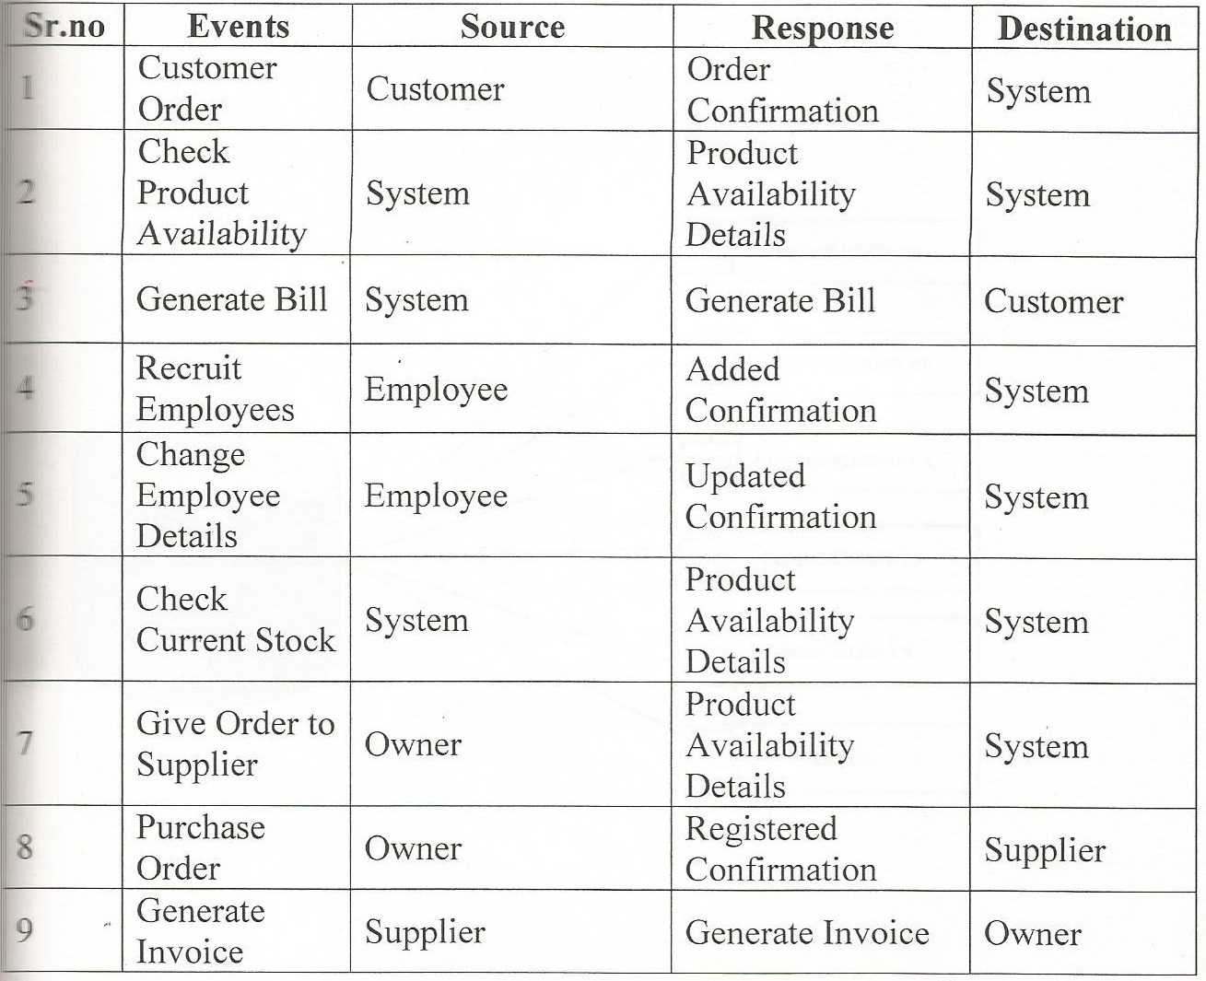

# DIAGRAMS

## ER Diagram

ER diagram is a graphical representation of entities and their relationships to each other, typically used in computing in regard to the organization of data within [databases](http://www.webopedia.com/TERM/D/database.html) or information systems. An entity is a piece of data-an [object](http://www.webopedia.com/TERM/O/object.html)or concept about which data is stored.

Eclipse which represents attributes.

Diamond which represents relationship sets.

Line which represents attributes to entity sets and entity sets to relationship sets.

Rectangle, which represent entity sets.

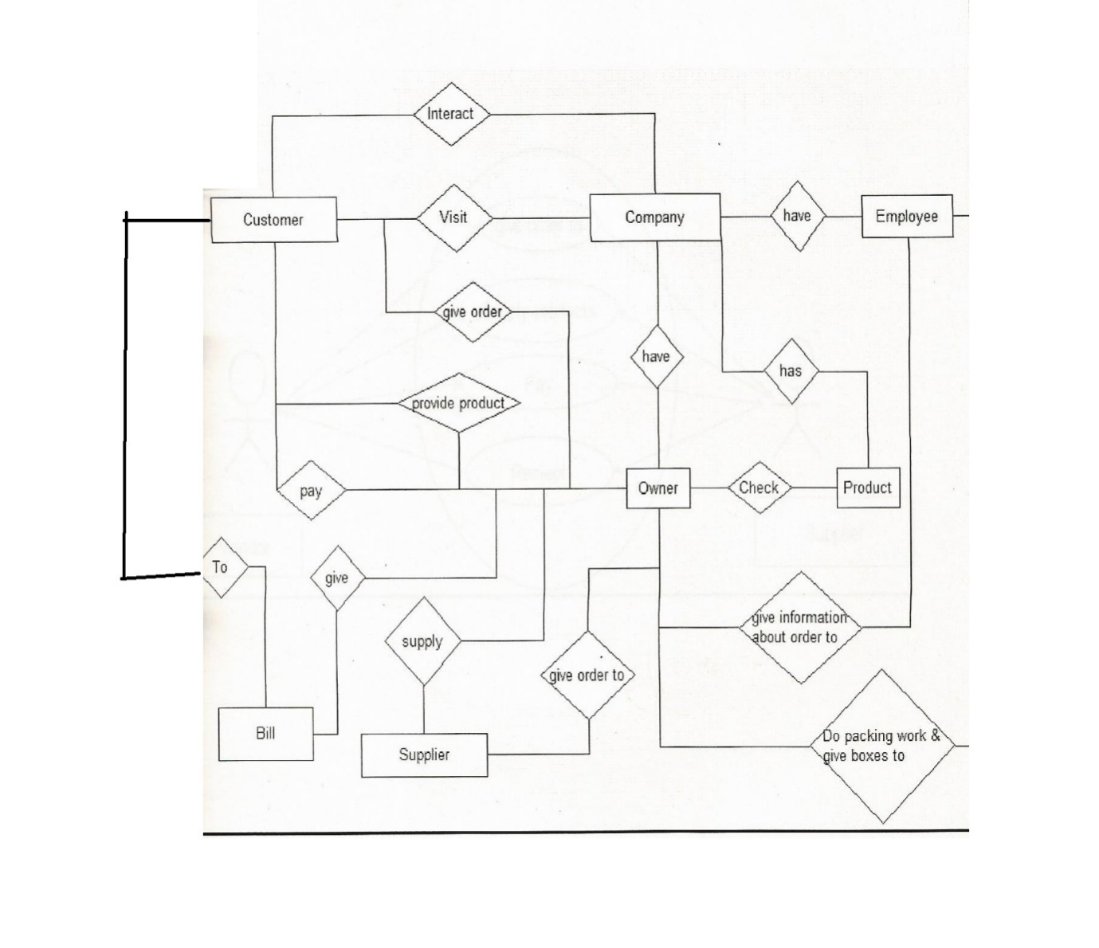

## 

## Use Case Diagram

The purpose of use case diagram is to capture the dynamic aspect of a system. But this definition is too generic to describe the purpose.

Use case diagrams are used to gather the requirements of a system including internal and external influences. These requirements are mostly design requirements. So when a system is analysed to gather its functionalities use cases are prepared and actors are identified.

Now when the initial task is complete use case diagrams are modelled to present the outside view.

Element of User cases:

Actor: An actor is any entity that performs certain rules.

System boundary: It defines the scope of what a system will be.

Association: This is use to show the participation of actor in use case.

Use case: Use case is visual representation of business functionality in system.

**Use Case Diagram**

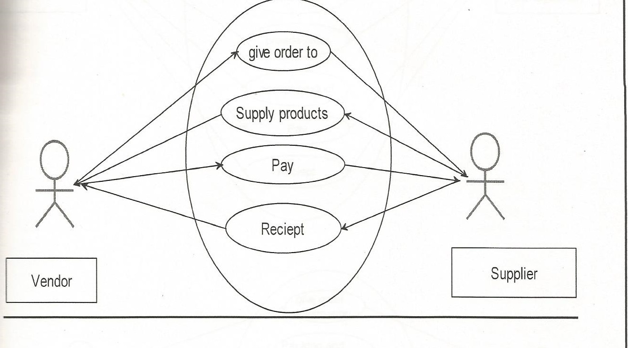

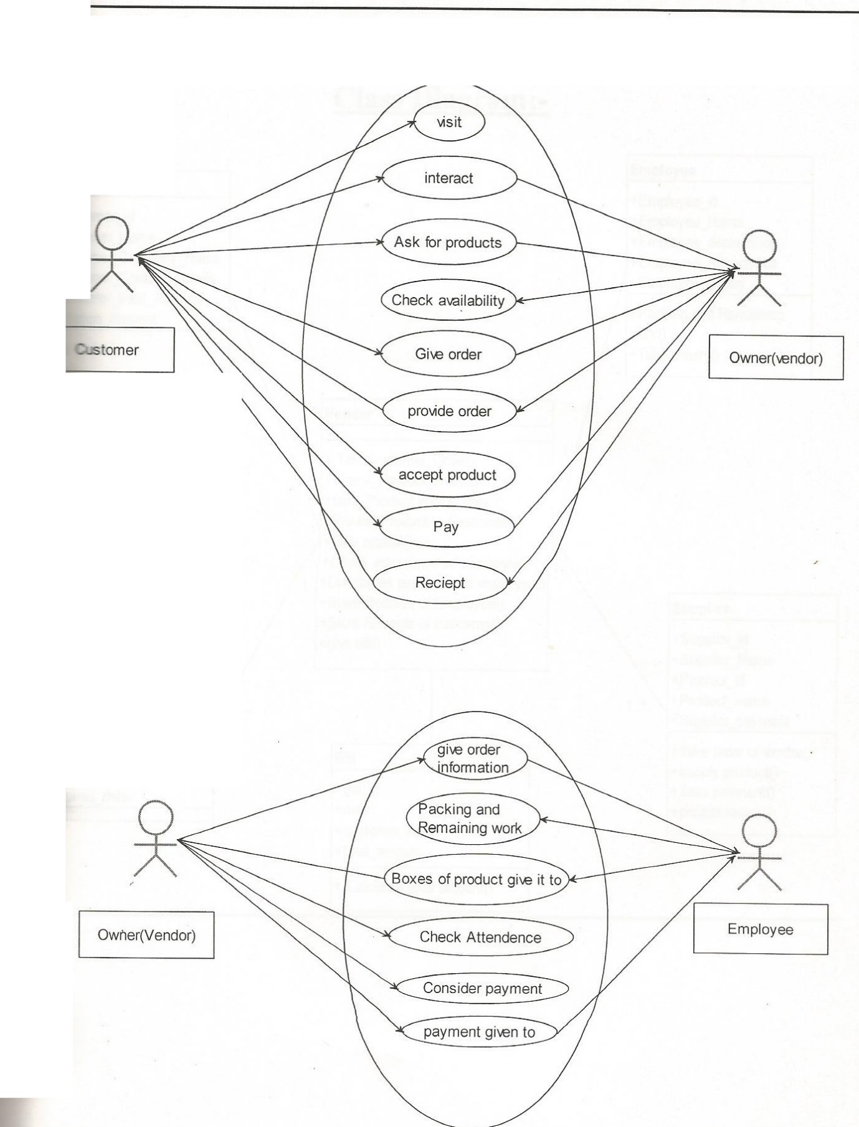

## Activity Diagram

Activity diagrams are graphical representations of [workflows](http://en.wikipedia.org/wiki/Workflow) of stepwise activities and actionswith support for choice, iteration and concurrency. In the [Unified Modelling Language](http://en.wikipedia.org/wiki/Unified_Modeling_Language), activity diagrams are intended to model both computational and organisational processes (i.e. workflows). Activity diagrams show the overall flow of control.

Element of Activity Diagram:

Initial Activity:This shows the starting point, there can be only one initial state.

Activity Description: Represents by rectangle with round edges.

Transition: Transitions are used mark with movement. Transitions are model using arrow.

Decisions: It is represented by the diamond with the option written oneither side of the arrow emerging from the diamond.

Synchronization bar (fork and joint): Activities can be done in parallel to split processing (fork).It denotes the beginning of parallel activity and joint denote the end of parallel processing.

Final Activity: It is an end of activity diagram shown with the bull’s eye.

**Admin Activity Diagram**

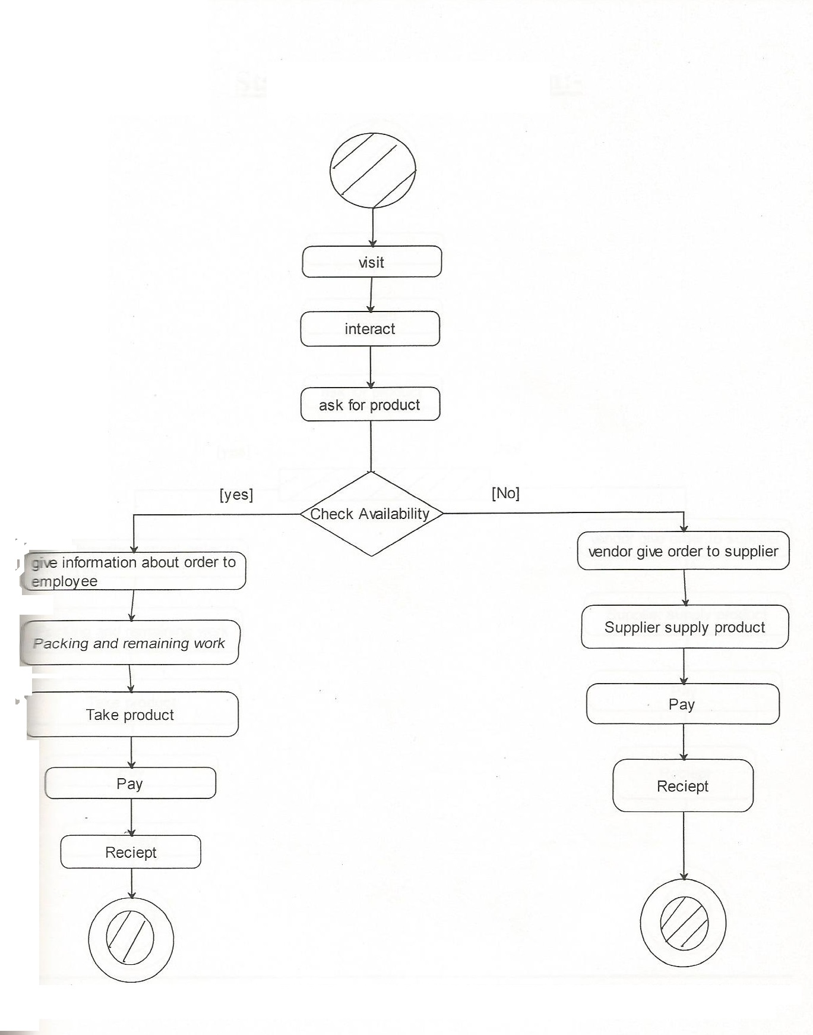

**Sequence Diagram**

Sequence diagram is the most common kind of [interaction diagram](http://www.uml-diagrams.org/uml-25-diagrams.html#interaction-diagram), which focuses on the [message](http://www.uml-diagrams.org/sequence-diagrams.html#message) interchange between a numbers of [lifelines](http://www.uml-diagrams.org/sequence-diagrams.html#lifeline).

Sequence diagram describes an interaction by focusing on the sequence of messages that are exchanged, along with their corresponding occurrence specifications on the lifelines.

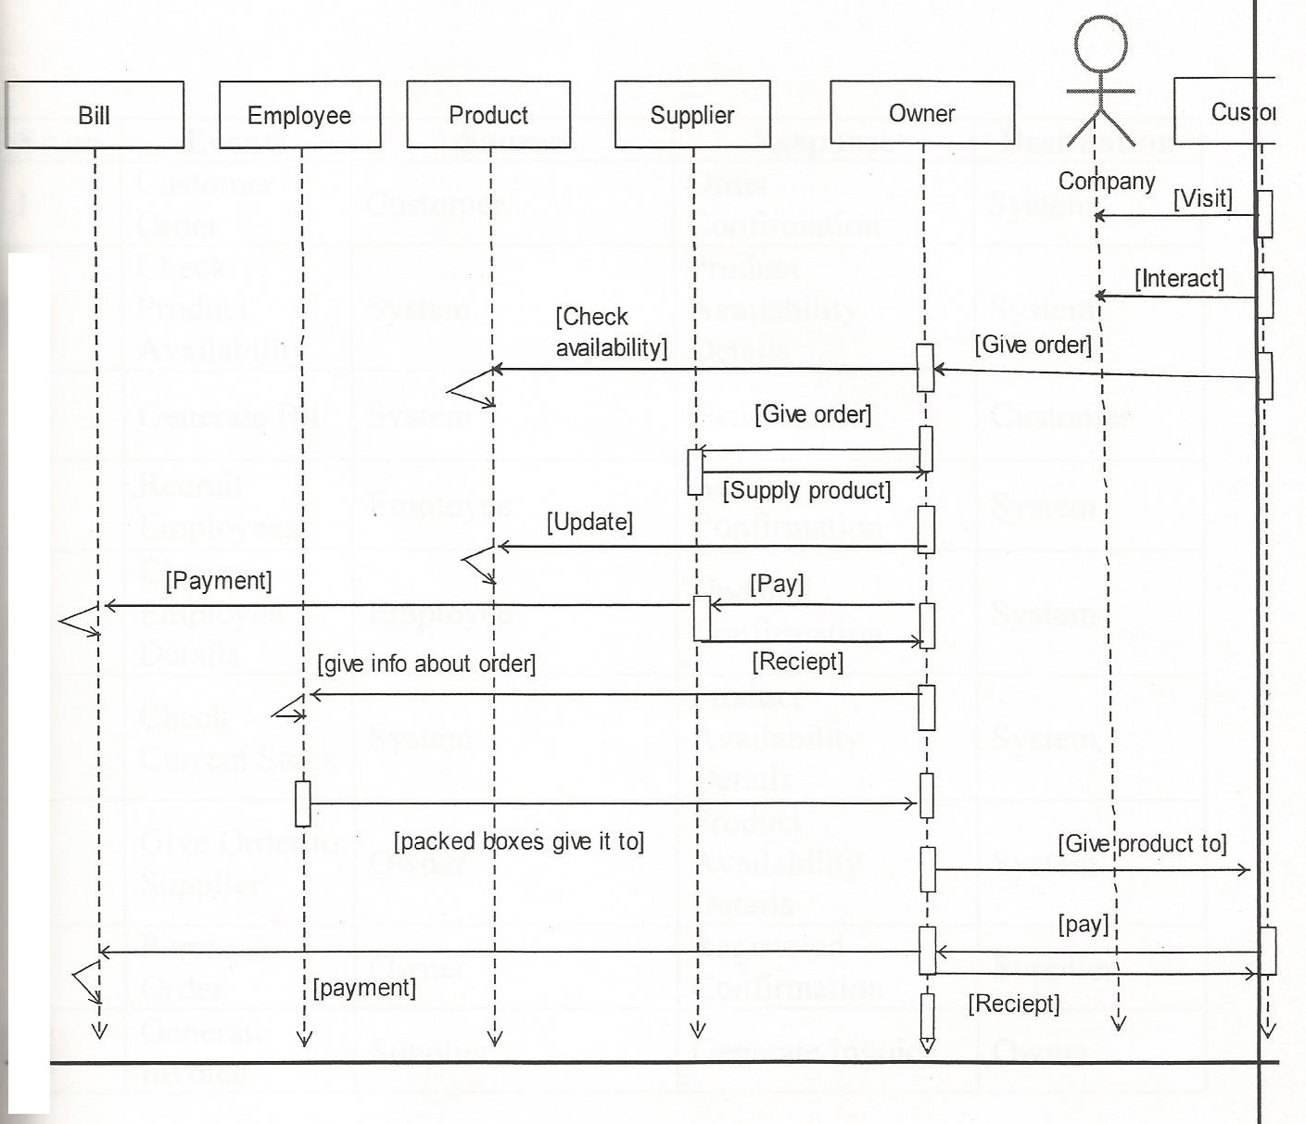

## Class Diagram

The purpose of the class diagram is to model the static view of an application. The class diagrams are the only diagrams which can be directly mapped with object oriented languages and thus widely used at the time of construction.

The UML diagrams like activity diagram, sequence diagram can only give the sequence flow of the application but class diagram is a bit different. So it is the most popular UML diagram in the coder community.

So the purpose of the class diagram can be summarized as:

* Analysis and design of the static view of an application.
* Describe responsibilities of a system.
* Base for component and deployment diagrams.
* Forward and reverse engineering.

Here we specify the class name.

Here we specify the attributes of the class.

Here we specify the List Of Functions.

**Class Diagram:**

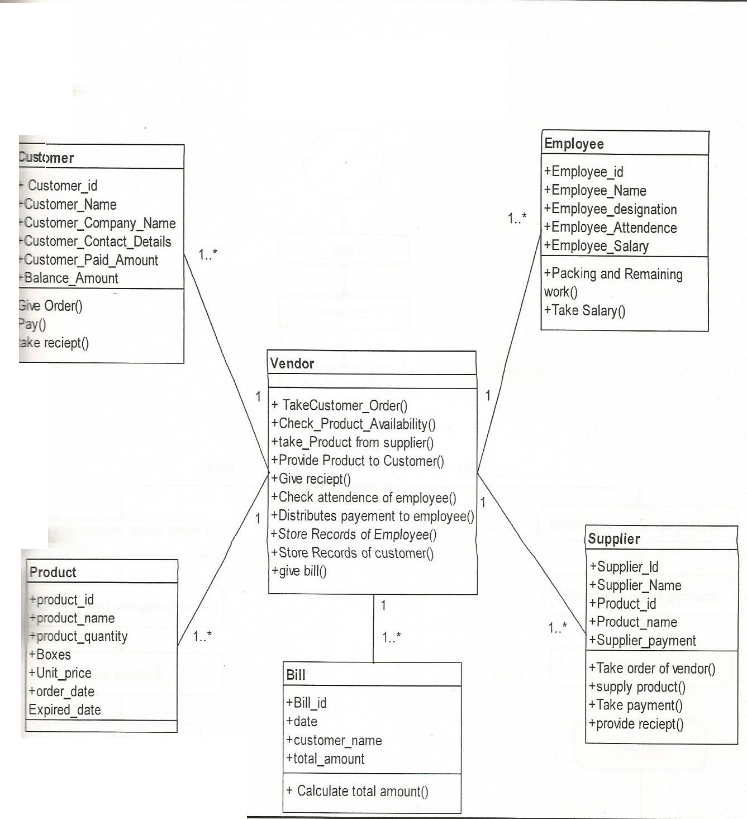

**State-transationDiagram :**

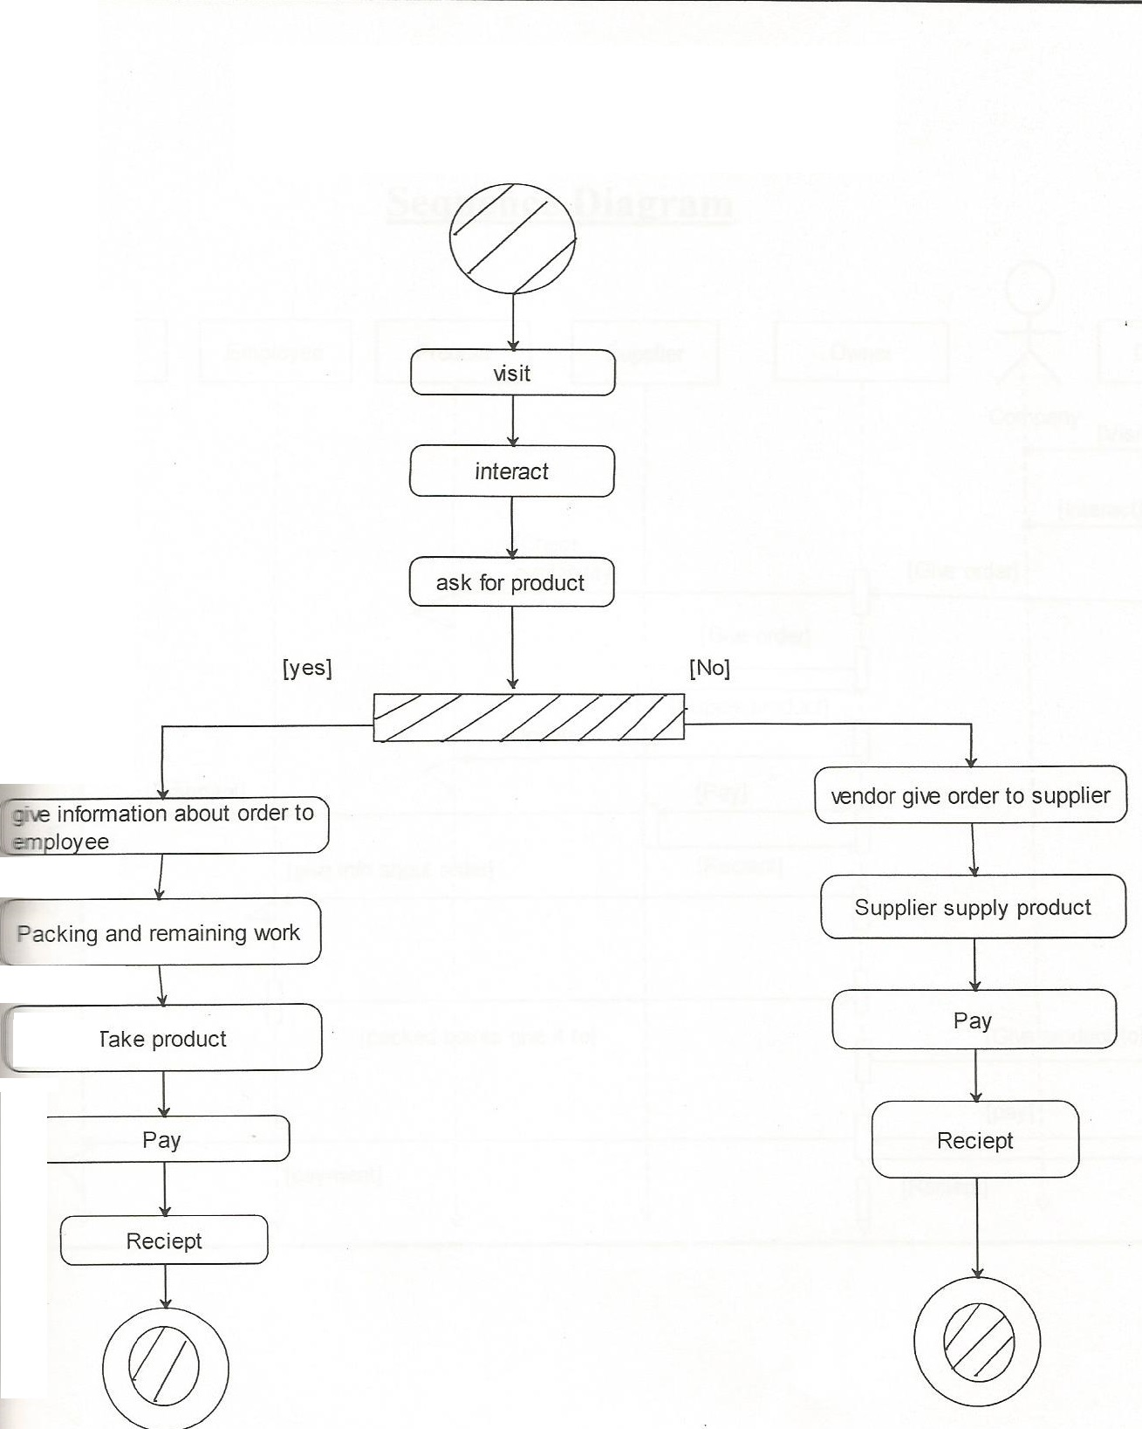

**component diagram**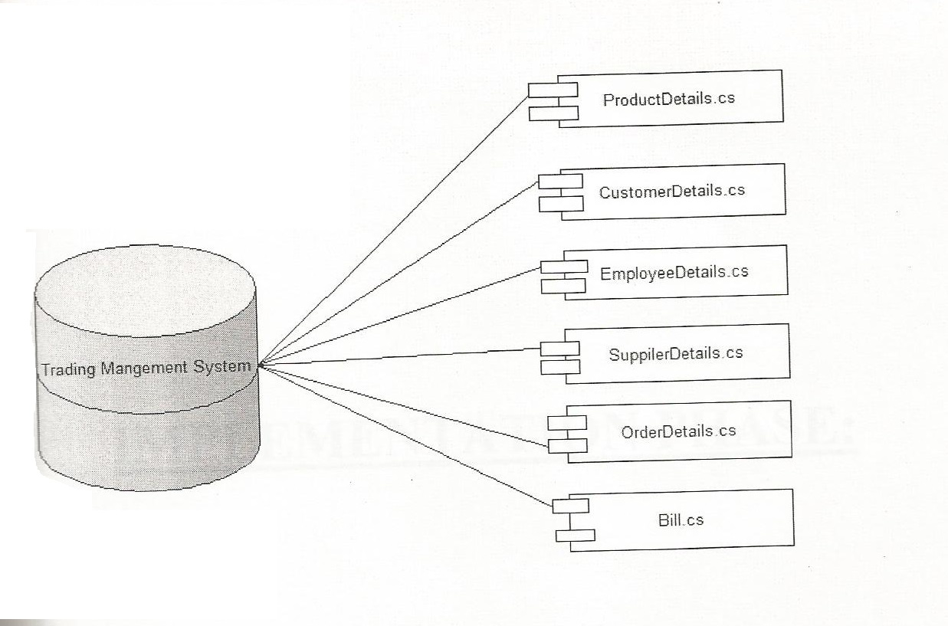

# SCREENSHOTS



**1.singup**

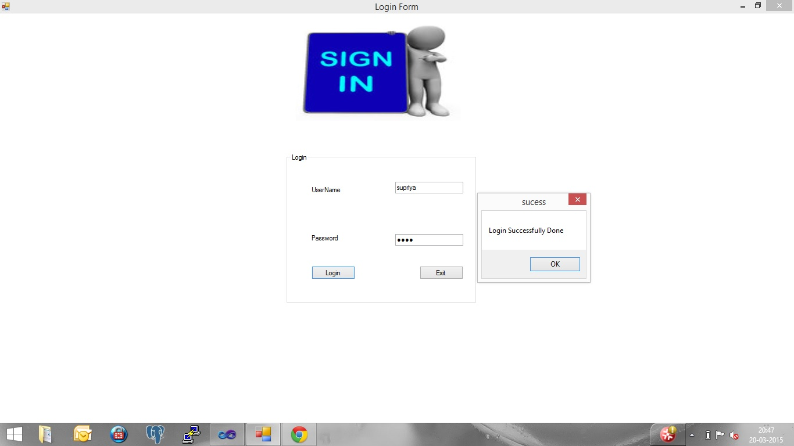

**2.ADD DRY FRUIT**

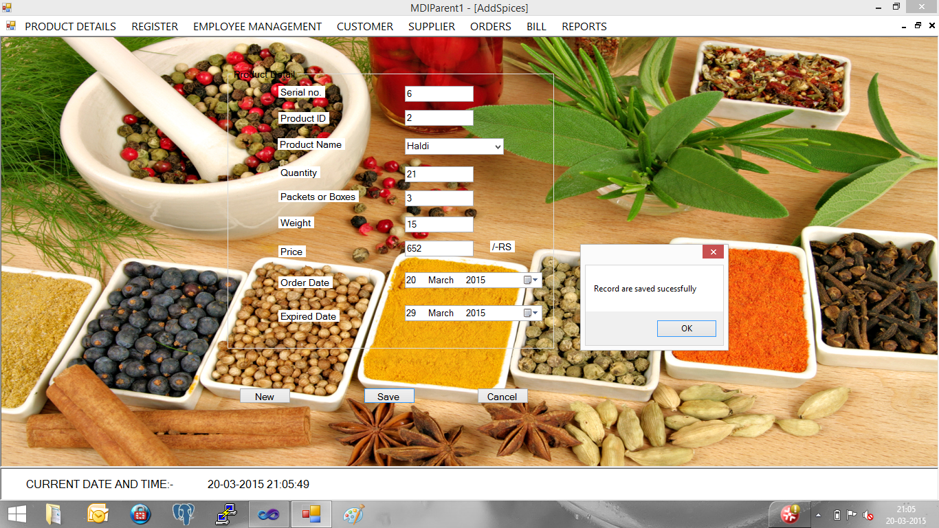

**3.SEARCH**

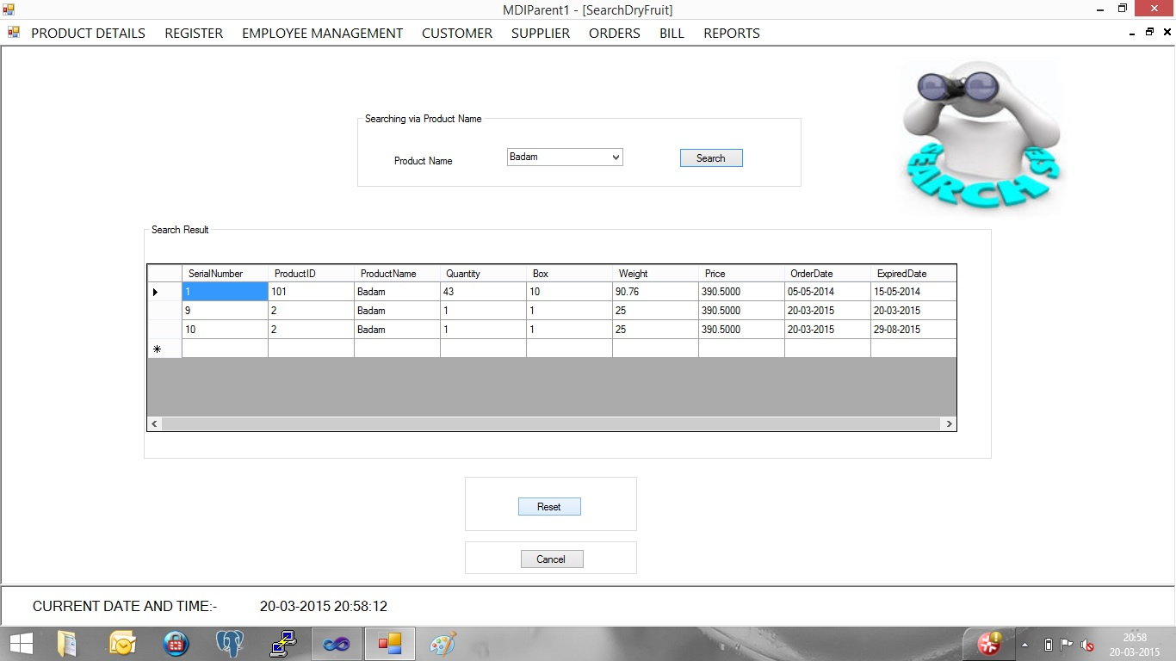

**4.UPDATE**

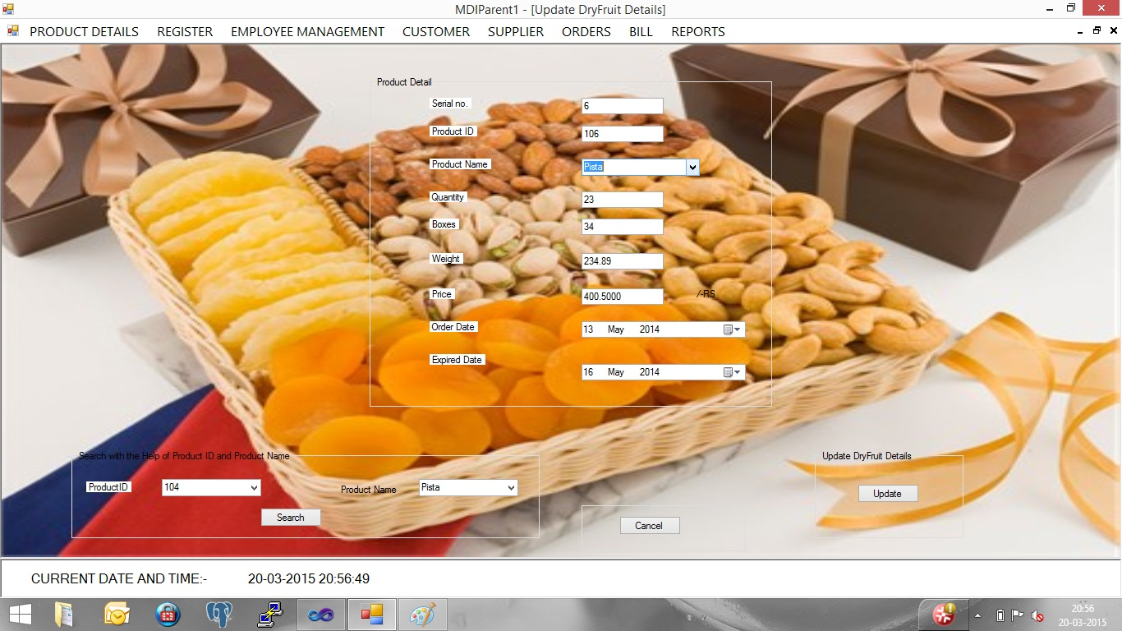

**5.DELETE**

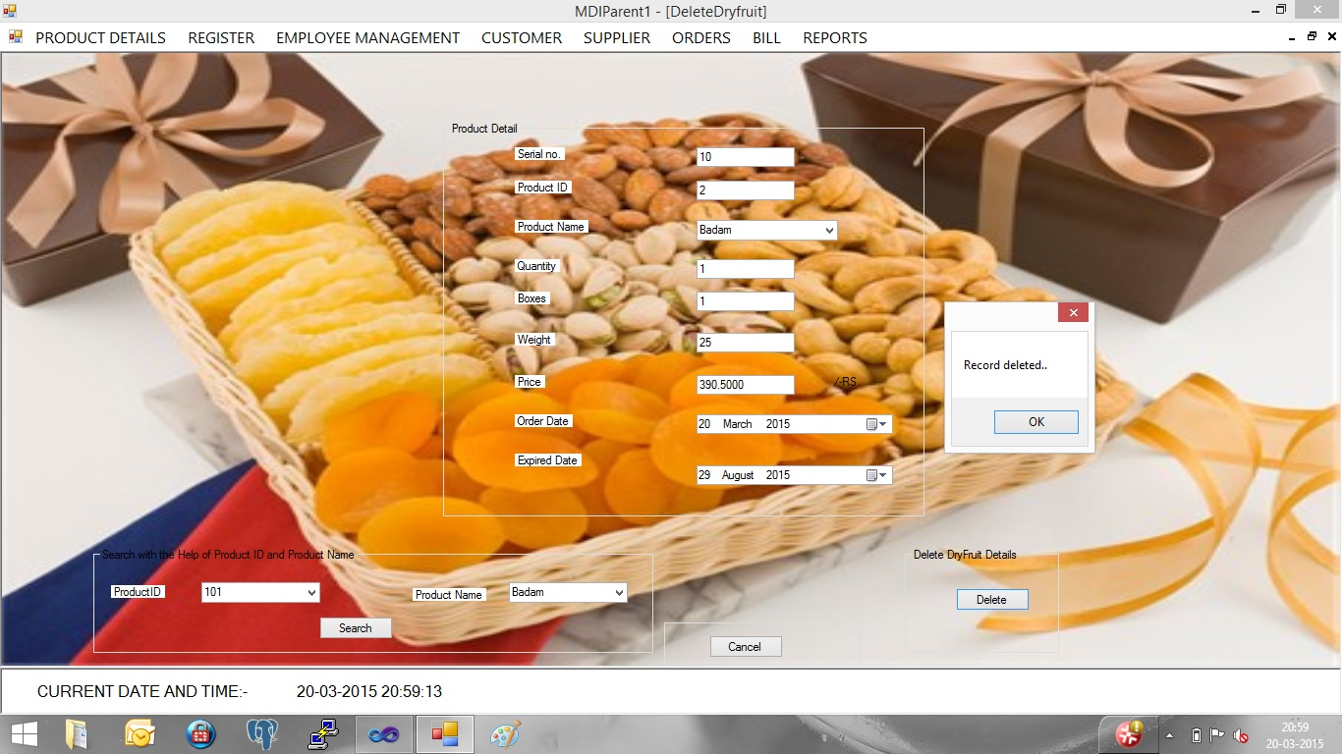

**6.RECORDS**

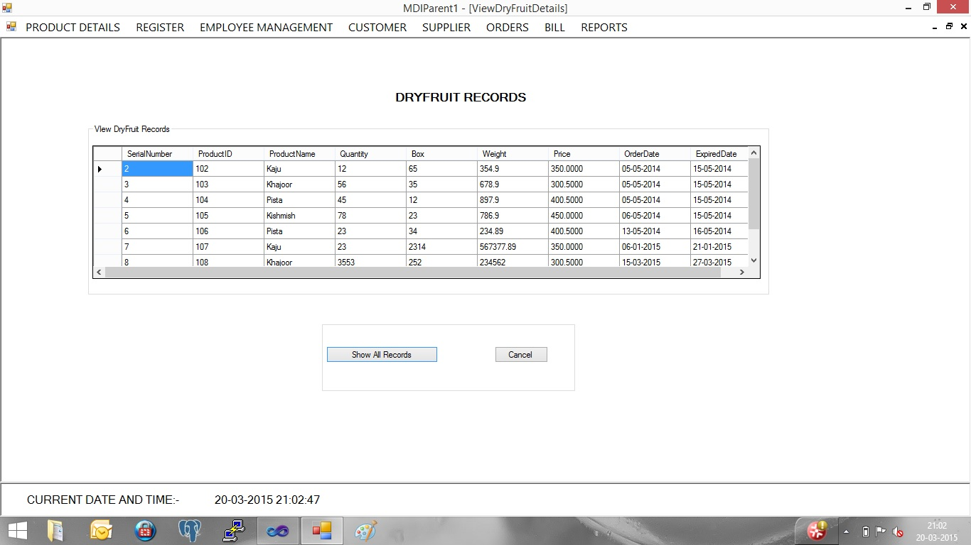

**7.EMP.REGITER**

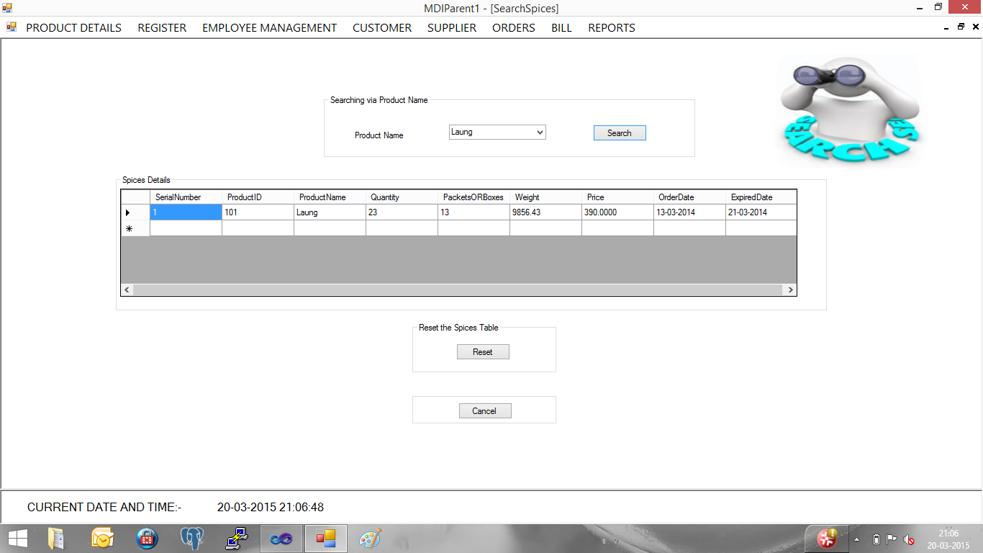

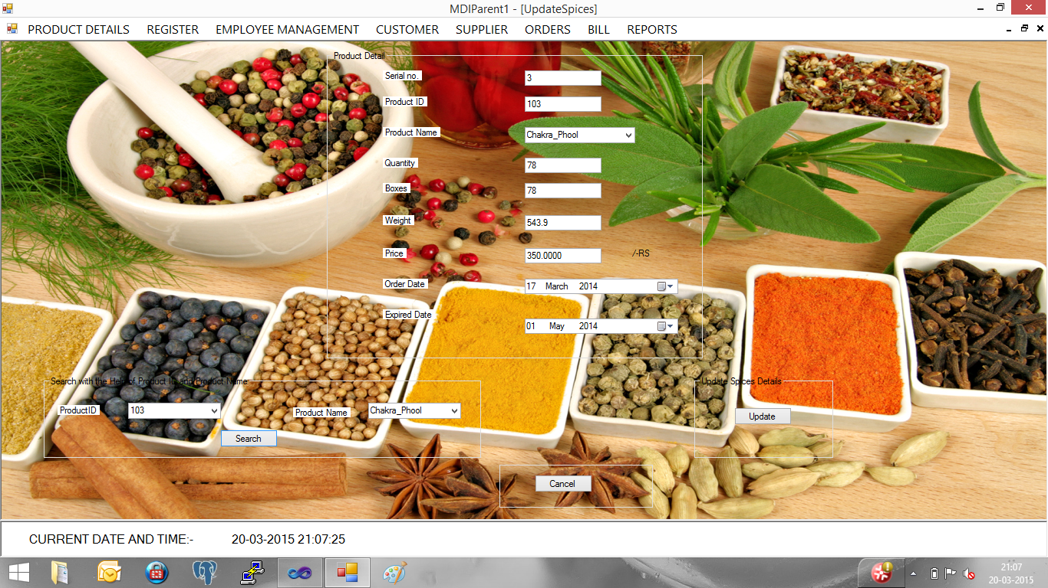

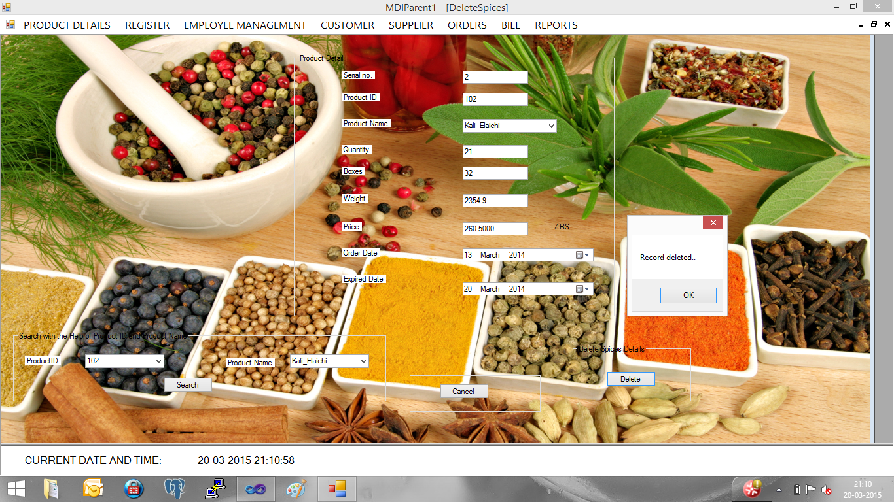

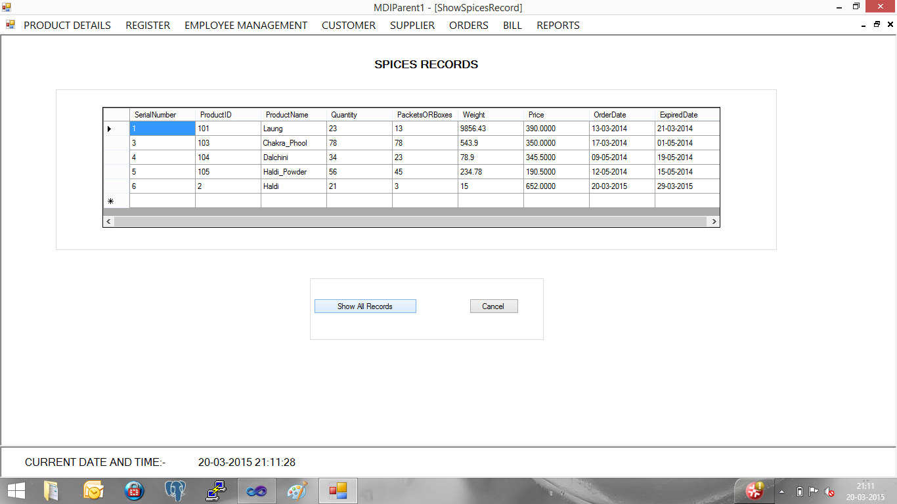

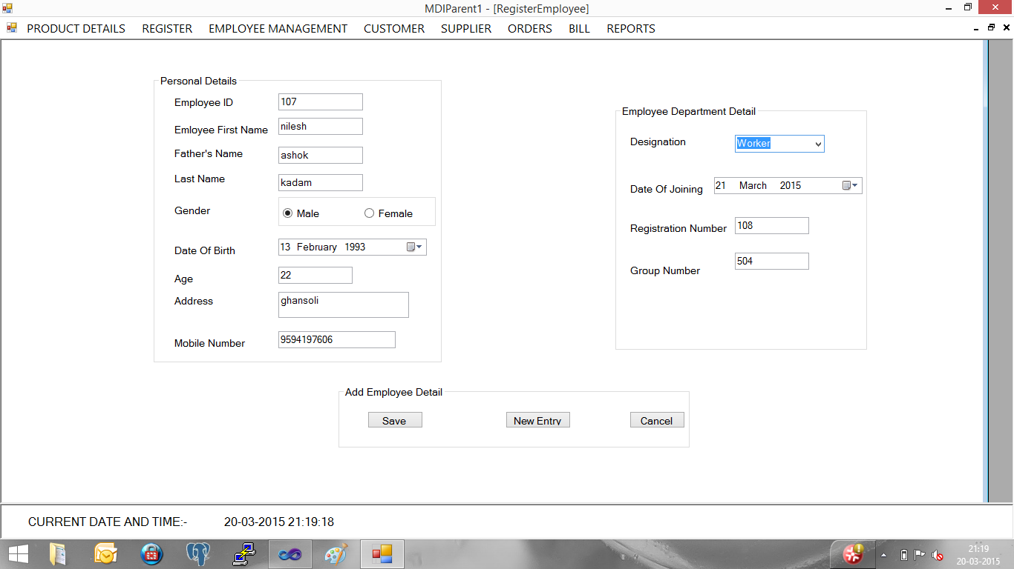

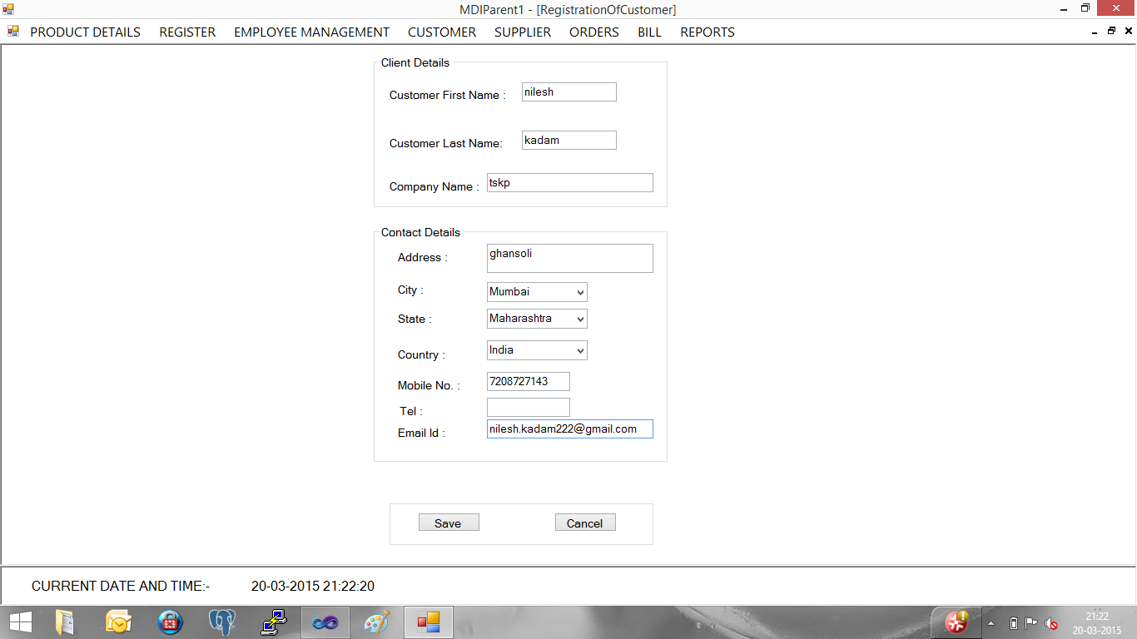

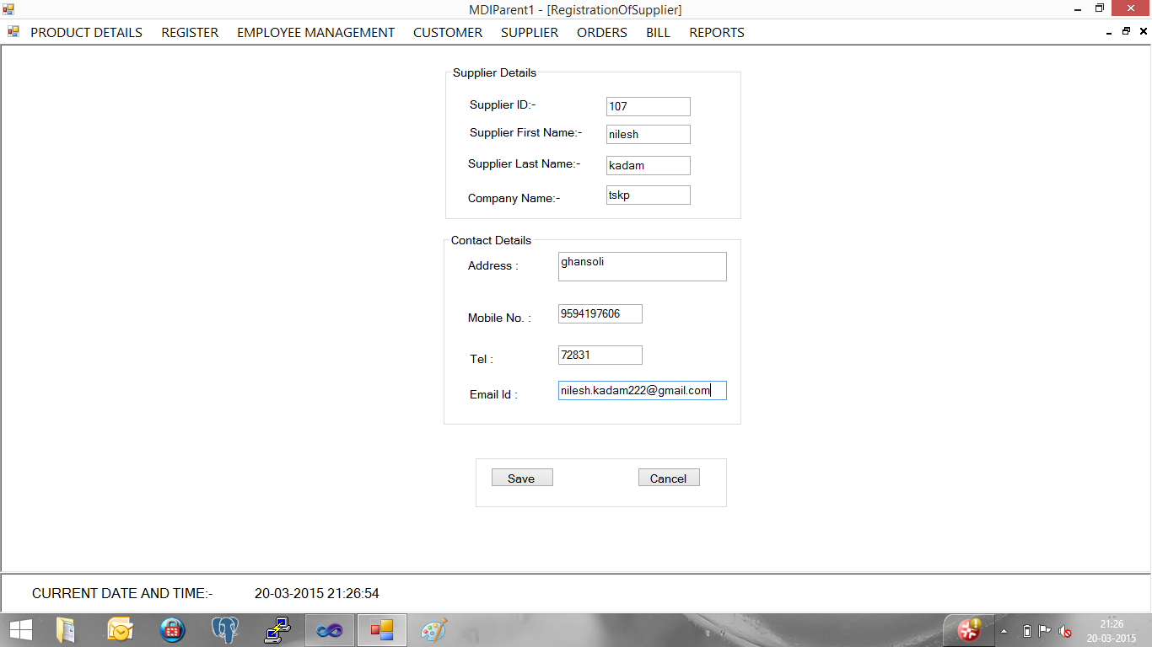

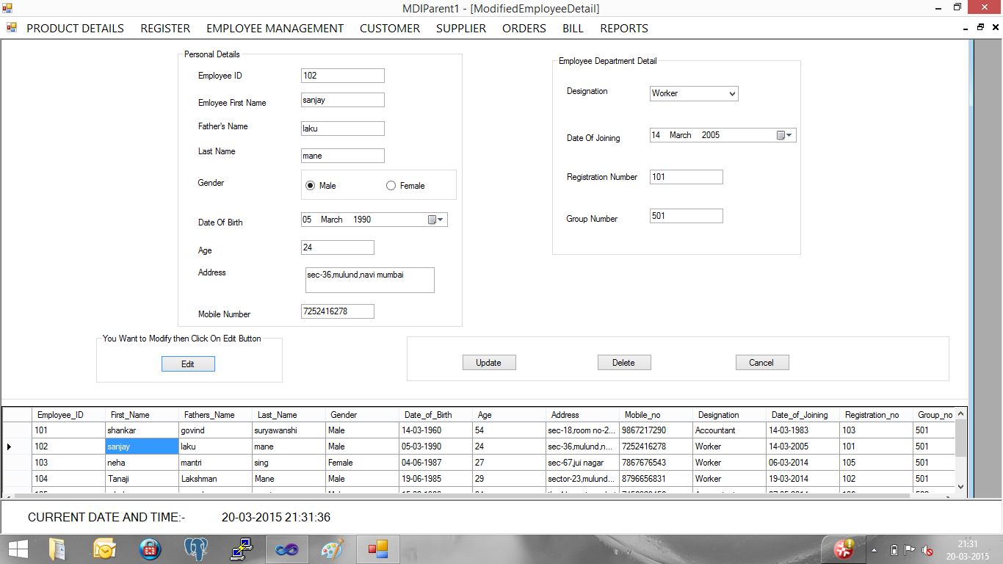

**4. Faculty Page**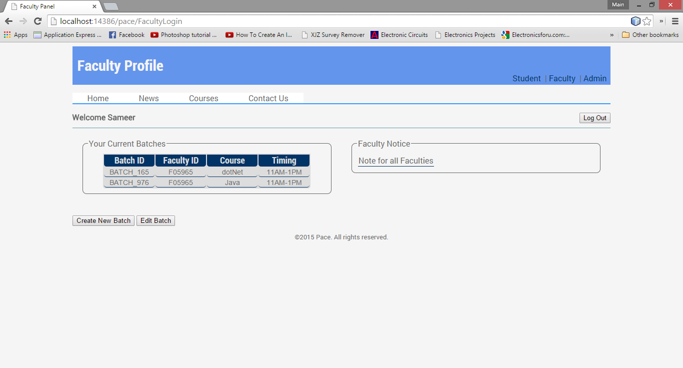

# TEST CASES& RESULTS

**1. Registration- Required field validation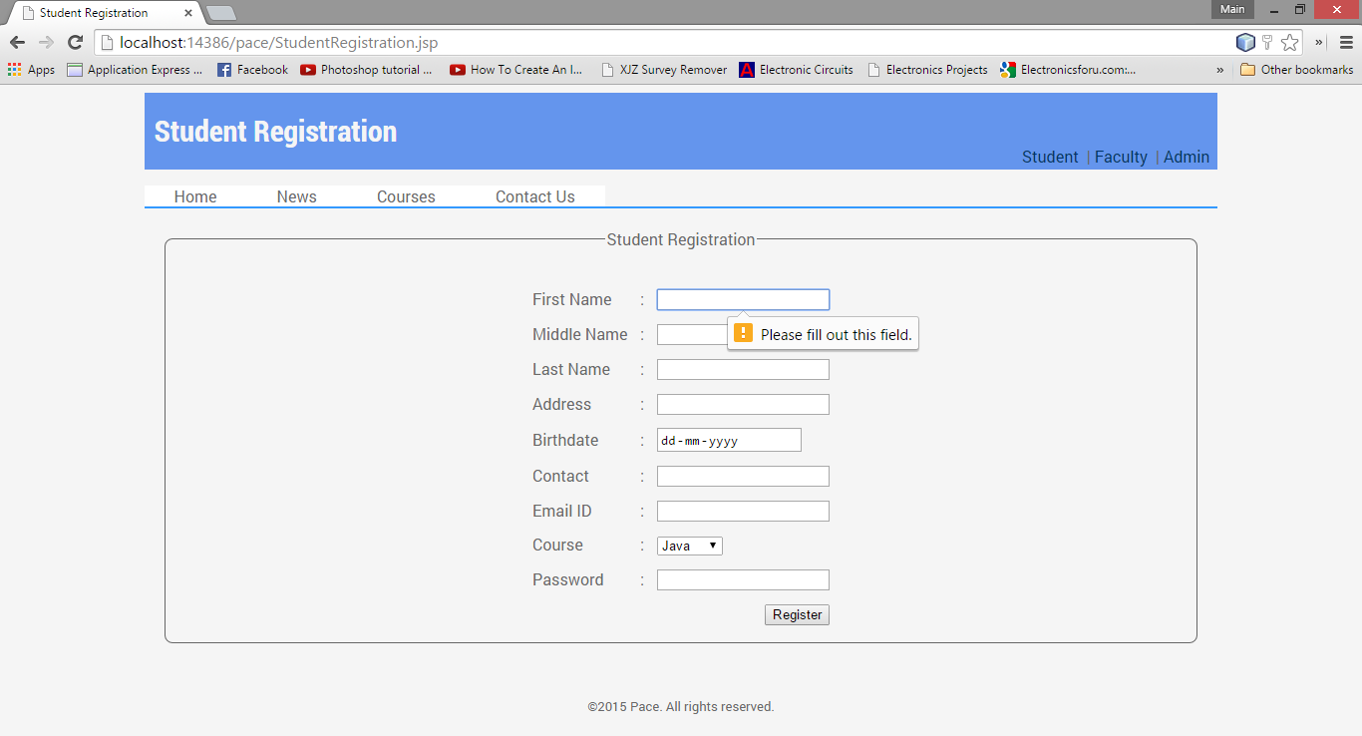 2. Invalid email**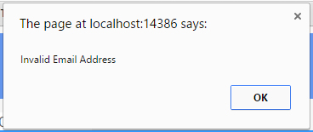

**3. Invalid Id/Password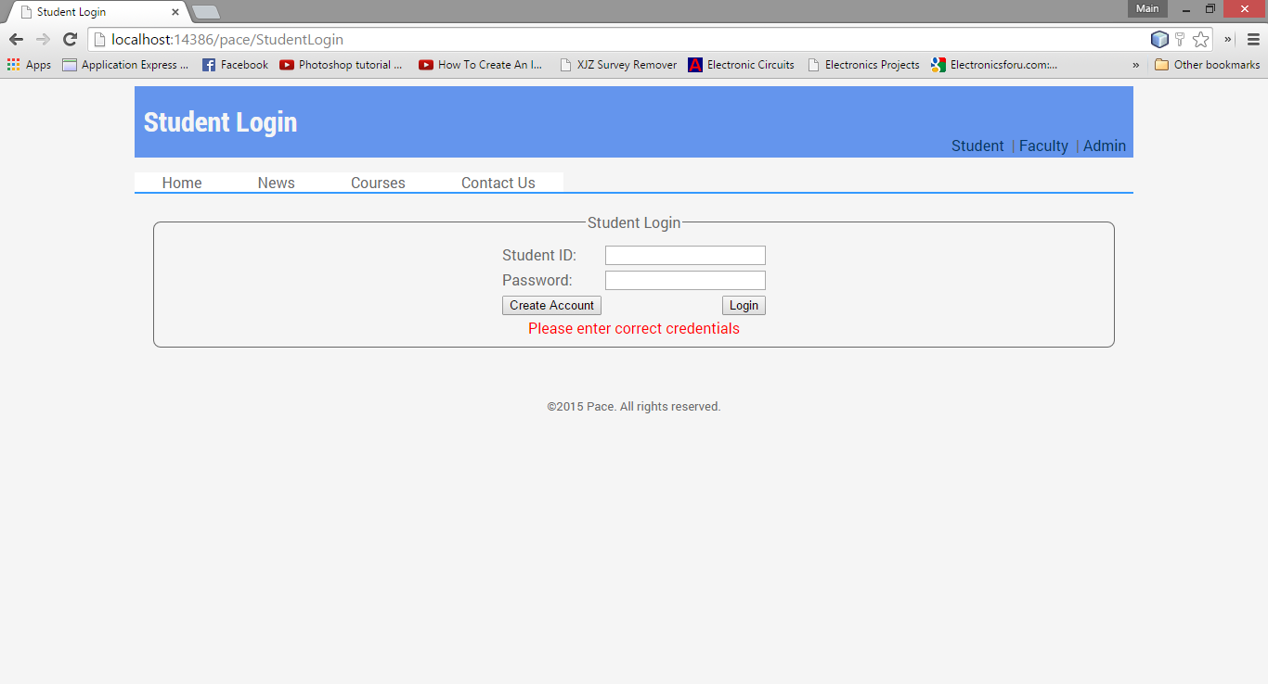 4. Invalid student/faculty**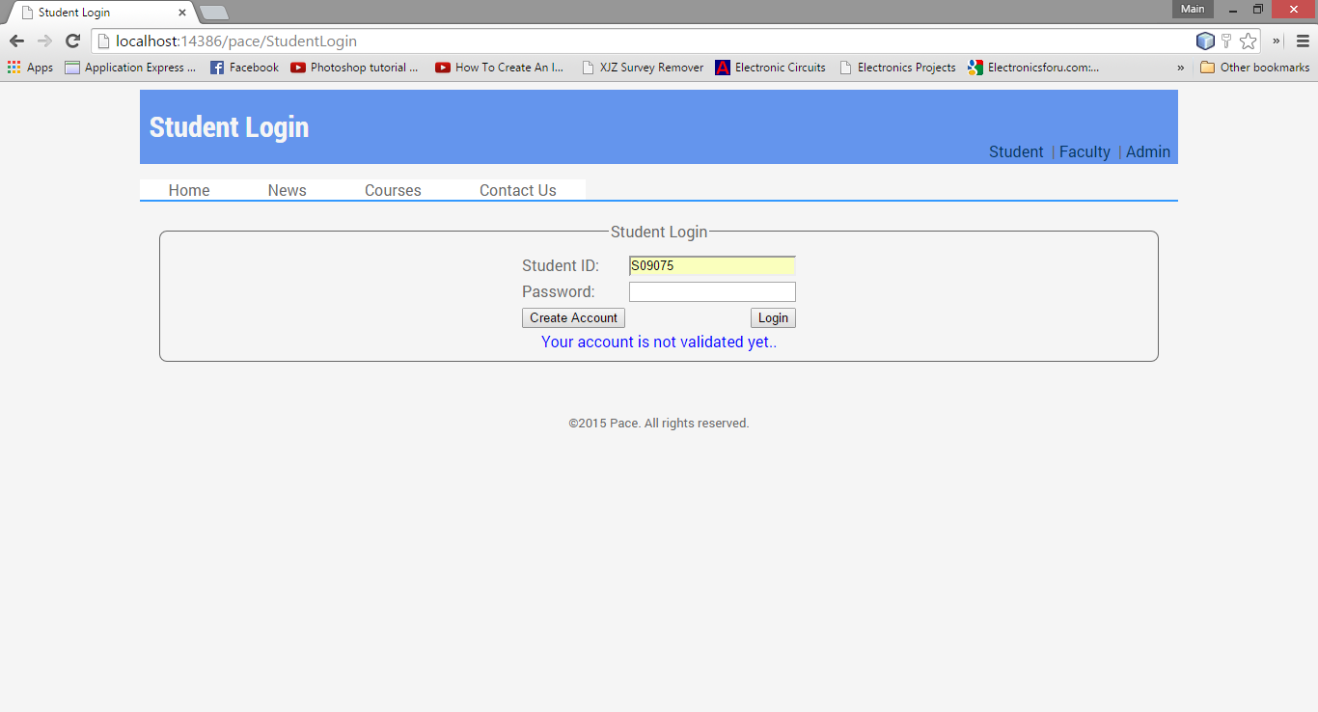

# REPORTS

**1. Batches**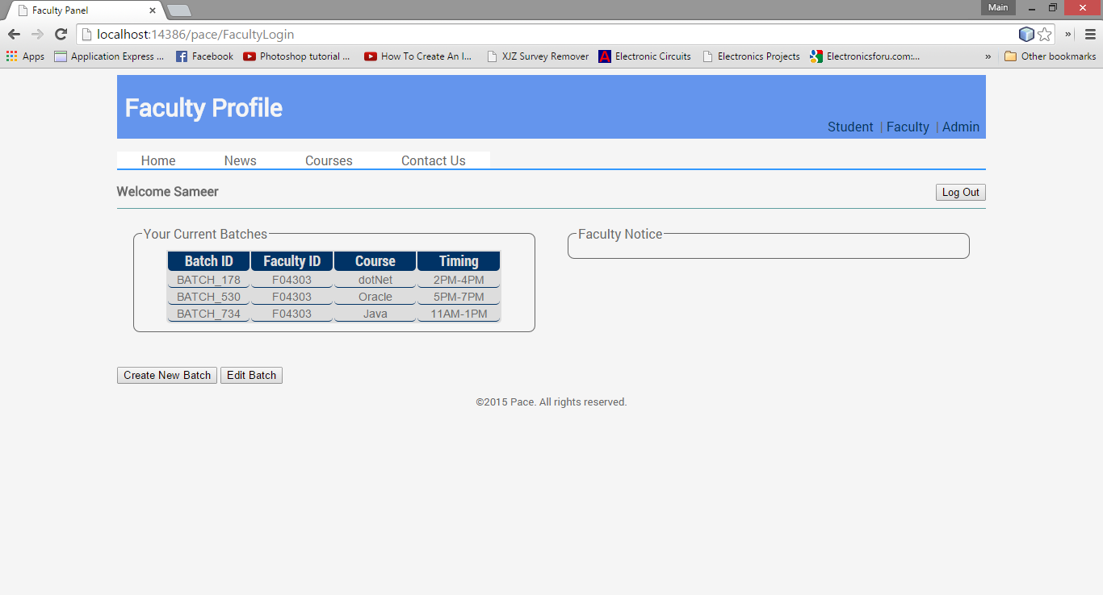

**2. Notice**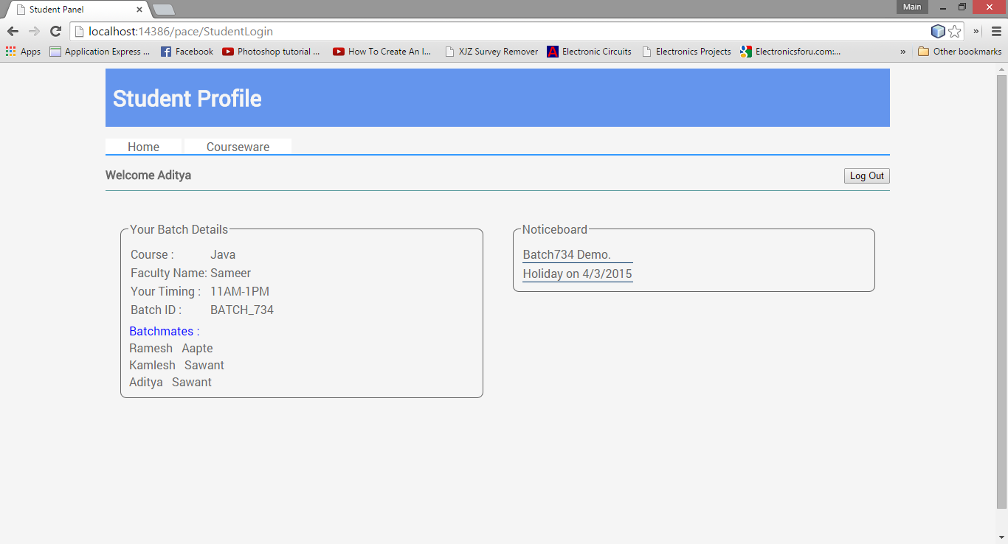

**3. Fees Invoice  
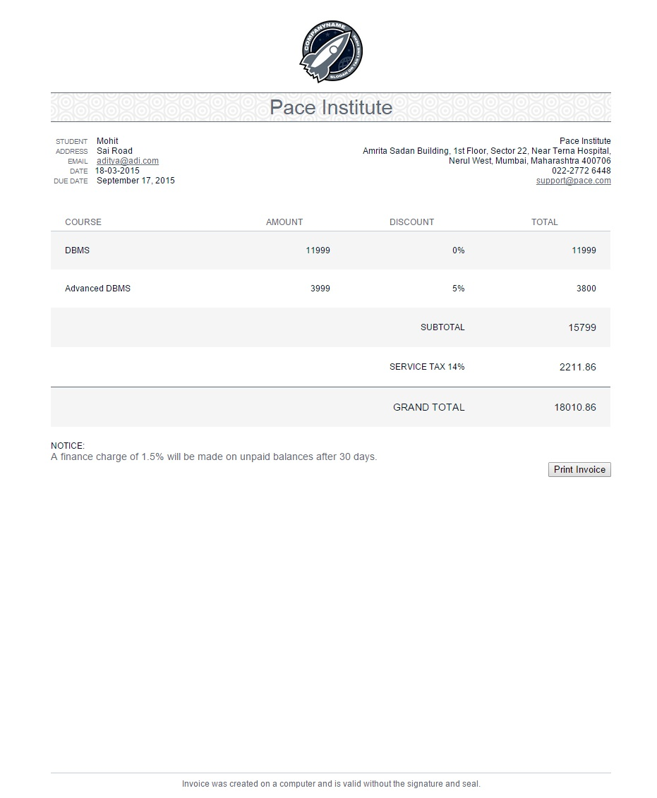**

System Coding

1.AddDryFruit.cs

using System;

using System.Collections.Generic;

using System.ComponentModel;

using System.Data;

using System.Drawing;

using System.Linq;

using System.Text;

using System.Windows.Forms;

using System.Data.SqlClient;

using System.Text.RegularExpressions;

namespace SangliTradingCompany

{

publicpartialclassAddDryFruit : Form

{

String c = Properties.Settings.Default.Database1ConnectionString;

SqlConnection con;

public AddDryFruit()

{

con = newSqlConnection(c);

InitializeComponent();

}

privatevoid validTextChar(object sender, EventArgs e)

{

TextBox T = (TextBox)sender;

try

{

//Not Allowing Numbers

char[] UnallowedCharacters = { '0', '1',

'2', '3',

'4', '5',

'6', '7',

'8', '9'};

if (textContainsUnallowedCharacter(T.Text, UnallowedCharacters))

{

int CursorIndex = T.SelectionStart - 1;

T.Text = T.Text.Remove(CursorIndex, 1);

//Align Cursor to same index

T.SelectionStart = CursorIndex;

T.SelectionLength = 0;

}

}

catch (Exception) { }

}

privatebool textContainsUnallowedCharacter(string T, char[] UnallowedCharacters)

{

for (int i = 0; i < UnallowedCharacters.Length; i++)

if (T.Contains(UnallowedCharacters[i]))

returntrue;

returnfalse;

}

privatevoid Save_btn_Click(object sender, EventArgs e)

{

if (serno_txt.Text != ""&& proid_txt.Text != ""&& Proname_cmbo.Text != ""&& quan_txt.Text != ""&& Box_txt.Text != ""&& weight_txt.Text != ""&& price_txt.Text != "")

{

con.Open();

SqlCommand cmd = newSqlCommand("insert into DryFruitTable values(@SerialNumber,@ProductID,@ProductName,@Quantity,@Box,@Weight,@Price,@OrderDate,@ExpiredDate)", con);

cmd.Parameters.AddWithValue("@SerialNumber", serno_txt.Text);

cmd.Parameters.AddWithValue("@ProductID", proid_txt.Text);

cmd.Parameters.AddWithValue("@ProductName", Proname_cmbo.Text);

cmd.Parameters.AddWithValue("@Quantity", quan_txt.Text);

cmd.Parameters.AddWithValue("@Box", Box_txt.Text);

cmd.Parameters.AddWithValue("@Weight", weight_txt.Text);

cmd.Parameters.AddWithValue("@Price", price_txt.Text);

cmd.Parameters.AddWithValue("@OrderDate", dateTimePicker1.Value);

cmd.Parameters.AddWithValue("@ExpiredDate", dateTimePicker2.Value);

cmd.ExecuteNonQuery();

con.Close();

MessageBox.Show("Record are saved sucessfully");

con.Close();

proid_txt.Clear();

quan_txt.Clear();

Box_txt.Clear();

price_txt.Clear();

weight_txt.Clear();

Proname_cmbo.Text = "";

}

else

{ MessageBox.Show("Please enter the value"); }

}

privatevoid textBox_KeyPress(object sender, KeyPressEventArgs e)

{

if (!char.IsControl(e.KeyChar)

&& !char.IsDigit(e.KeyChar)

&& e.KeyChar != '.')

{

e.Handled = true;

}

// only allow one decimal point

if (e.KeyChar == '.'

&& (sender asTextBox).Text.IndexOf('.') > -1)

{

e.Handled = true;

}

}

privatevoid validTextInteger(object sender, EventArgs e)

{

Exception X = newException();

TextBox T = (TextBox)sender;

try

{

if (T.Text != "-")

{

int x = int.Parse(T.Text);

}

}

catch (Exception)

{

try

{

int CursorIndex = T.SelectionStart - 1;

T.Text = T.Text.Remove(CursorIndex, 1);

//Align Cursor to same index

T.SelectionStart = CursorIndex;

T.SelectionLength = 0;

}

catch (Exception) { }

}

}

privatevoid AddDryFruit_Load(object sender, EventArgs e)

{

MDIParent1 f = newMDIParent1();

f.Hide();

using (SqlCommand comd = newSqlCommand("Select isnull(max(SerialNumber),0) from DryFruitTable", con))

{

con.Open();

object result = comd.ExecuteScalar();

con.Close();

serno_txt.Text = (int.Parse(result.ToString()) + 1).ToString();

}

}

privatevoid cancel_btn_Click(object sender, EventArgs e)

{

this.Hide();

}

privatevoid Newentry_btn_Click(object sender, EventArgs e)

{

proid_txt.Clear();

quan_txt.Clear();

Box_txt.Clear();

price_txt.Clear();

weight_txt.Clear();

Proname_cmbo.Text = "";

using (SqlCommand comd = newSqlCommand("Select isnull(max(SerialNumber),0) from DryFruitTable", con))

{

con.Open();

object result = comd.ExecuteScalar();

con.Close();

serno_txt.Text = (int.Parse(result.ToString()) + 1).ToString();

}

}

privatevoid serno_txt_KeyPress(object sender, KeyPressEventArgs e)

{

if (!char.IsControl(e.KeyChar)

&& !char.IsDigit(e.KeyChar)

)

{

e.Handled = true;

}

}

privatevoid Proname_cmbo_SelectedIndexChanged_1(object sender, EventArgs e)

{

if (Proname_cmbo.SelectedItem.ToString() == "Badam")

{

price_txt.Text = "390.50";

}

elseif (Proname_cmbo.SelectedItem.ToString() == "Kaju")

{

price_txt.Text = "350";

}

elseif (Proname_cmbo.SelectedItem.ToString() == "Khajoor")

{

price_txt.Text = "300.50";

}

elseif (Proname_cmbo.SelectedItem.ToString() == "Pista")

{

price_txt.Text = "400.50";

}

elseif (Proname_cmbo.SelectedItem.ToString() == "Kishmish")

{

price_txt.Text = "450";

}

elseif (Proname_cmbo.SelectedItem.ToString() == "Akhrot")

{

price_txt.Text = "460.50";

}

else

{

price_txt.Text = "";

}

}

}

}

Bill.cs

using System;

using System.Collections.Generic;

using System.ComponentModel;

using System.Data;

using System.Drawing;

using System.Linq;

using System.Text;

using System.Windows.Forms;

using System.Data.SqlClient;

namespace SangliTradingCompany

{

publicpartialclassBill : Form

{

String c = Properties.Settings.Default.Database1ConnectionString;

SqlConnection con;

public Bill()

{

con = newSqlConnection(c);

InitializeComponent();

}

privatevoid amount1_txt_TextChanged(object sender, EventArgs e)

{

decimal a;

a = Convert.ToDecimal(netkg1_txt.Text) * Convert.ToDecimal(price1_txt.Text);

amount1_txt.Text = a.ToString();

}

privatevoid amount2_txt_TextChanged(object sender, EventArgs e)

{

decimal a;

a = Convert.ToDecimal(netkg2_txt.Text) * Convert.ToDecimal(price2_txt.Text);

amount2_txt.Text = a.ToString();

}

privatevoid amount4_txt_TextChanged(object sender, EventArgs e)

{

decimal a;

a = Convert.ToDecimal(netkg4_txt.Text) * Convert.ToDecimal(price4_txt.Text);

amount4_txt.Text = a.ToString();

}

privatevoid total_btn_Click(object sender, EventArgs e)

{

decimal a, b, c, d,e2;

a = Convert.ToDecimal(amount1_txt.Text);

b = Convert.ToDecimal(amount2_txt.Text);

c = Convert.ToDecimal(amount3_txt.Text);

d = Convert.ToDecimal(amount4_txt.Text);

e2 = Convert.ToDecimal(amount5_txt.Text);

total_amount_txt.Text = (a+b+c+d+e2).ToString();

}

privatevoid amount3_txt_TextChanged(object sender, EventArgs e)

{

decimal a;

a = Convert.ToDecimal(netkg3_txt.Text) * Convert.ToDecimal(price3_txt.Text);

amount3_txt.Text = a.ToString();

}

privatevoid amount5_txt_TextChanged(object sender, EventArgs e)

{

decimal a;

a = Convert.ToDecimal(netkg5_txt.Text) * Convert.ToDecimal(price5_txt.Text);

amount5_txt.Text = a.ToString();

}

privatevoid Save_btn_Click(object sender, EventArgs e)

{

con.Open();

string cmd = "insert into Bill_Table values('" + Firstname_combo.Text + "','" + lastname_combo.Text + "', '" + comp_combo.Text + "','" + add_txt.Text + "','" + bill_number.Text + "','" + dateTimePicker1.Value + "','" + proname1_combo.Text + "','" + q1_txt.Text + "','" + netkg1_txt.Text + "','" + price1_txt.Text + "' ,'" + amount1_txt.Text + "','" + proname2_combo.Text + "','" + q2_txt.Text + "','" + netkg2_txt.Text + "','" + price2_txt.Text + "','" + amount2_txt.Text + "','" + proname3_combo.Text + "','" + q3_txt.Text + "','" + netkg3_txt.Text + "','" + price3_txt.Text + "','" + amount3_txt.Text + "','" + proname4_combo.Text + "','" + q4_txt.Text + "','" + netkg4_txt.Text + "','" + price4_txt.Text + "','" + amount4_txt.Text + "','" + proname5_combo.Text + "','" + q5_txt.Text + "','" + netkg5_txt.Text + "','" + price5_txt.Text + "','" + amount5_txt.Text + "','"+total_amount_txt.Text+"')";

SqlCommand insert = newSqlCommand(cmd, con);

try

{

insert.ExecuteNonQuery();

MessageBox.Show("Bill Record of Customer are registered successfully...............");

}

catch (Exception ex)

{

MessageBox.Show(ex.Message);

}

con.Close();

add_txt.Clear();

bill_number.Clear();

proname1_combo.Text = "";

proname2_combo.Text = "";

proname3_combo.Text="";

proname4_combo.Text="";

proname5_combo.Text="";

q1_txt.Clear();

q2_txt.Clear();

q3_txt.Clear();

q4_txt.Clear();

q5_txt.Clear();

netkg1_txt.Clear();

netkg2_txt.Clear();

netkg3_txt.Clear();

netkg4_txt.Clear();

netkg5_txt.Clear();

price1_txt.Clear();

price2_txt.Clear();

price3_txt.Clear();

price4_txt.Clear();

price5_txt.Clear();

amount1_txt.Clear();

amount2_txt.Clear();

amount3_txt.Clear();

amount4_txt.Clear();

amount5_txt.Clear();

total_amount_txt.Clear();

}

privatevoid groupBox1_Enter(object sender, EventArgs e)

{

}

privatevoid Bill_Load(object sender, EventArgs e)

{

con.Open();

string query = "select Customer_First_Name,Customer_Last_Name,Company_Name from Customer_Table";

SqlDataAdapter da = newSqlDataAdapter(query, con);

DataSet ds = newDataSet();

DataTable dt = newDataTable();

da.Fill(ds);

da.Fill(dt);

Firstname_combo.DataSource = ds.Tables[0];

lastname_combo.DataSource = ds.Tables[0];

comp_combo.DataSource = ds.Tables[0];

Firstname_combo.DisplayMember = "Customer_First_Name";

lastname_combo.DisplayMember = "Customer_Last_Name";

comp_combo.DisplayMember = "Company_Name";

con.Close();

using (SqlCommand comd = newSqlCommand("Select isnull(max(Bill_Number),0) from Bill_Table", con))

{

con.Open();

object result = comd.ExecuteScalar();

con.Close();

bill_number.Text = (int.Parse(result.ToString()) + 1).ToString();

}

}

privatevoid new_btn_Click(object sender, EventArgs e)

{

using (SqlCommand comd = newSqlCommand("Select isnull(max(Bill_Number),0) from Bill_Table", con))

{

con.Open();

object result = comd.ExecuteScalar();

con.Close();

bill_number.Text = (int.Parse(result.ToString()) + 1).ToString();

}

}

privatevoid Cancel_btn_Click(object sender, EventArgs e)

{

this.Hide();

}

}

}

CustomberDForder.cs

using System;

using System.Collections.Generic;

using System.ComponentModel;

using System.Data;

using System.Drawing;

using System.Linq;

using System.Text;

using System.Windows.Forms;

using System.Data.SqlClient;

namespace SangliTradingCompany

{

publicpartialclassCustomerDFOrder : Form

{

String c = Properties.Settings.Default.Database1ConnectionString;

SqlConnection con;

public CustomerDFOrder()

{

con = newSqlConnection(c);

InitializeComponent();

}

privatevoid validTextChar(object sender, EventArgs e)

{

TextBox T = (TextBox)sender;

try

{

//Not Allowing Numbers

char[] UnallowedCharacters = { '0', '1',

'2', '3',

'4', '5',

'6', '7',

'8', '9'};

if (textContainsUnallowedCharacter(T.Text, UnallowedCharacters))

{

int CursorIndex = T.SelectionStart - 1;

T.Text = T.Text.Remove(CursorIndex, 1);

//Align Cursor to same index

T.SelectionStart = CursorIndex;

T.SelectionLength = 0;

}

}

catch (Exception) { }

}

privatebool textContainsUnallowedCharacter(string T, char[] UnallowedCharacters)

{

for (int i = 0; i < UnallowedCharacters.Length; i++)

if (T.Contains(UnallowedCharacters[i]))

returntrue;

returnfalse;

}

privatevoid textBox_KeyPress(object sender, KeyPressEventArgs e)

{

if (!char.IsControl(e.KeyChar)

&& !char.IsDigit(e.KeyChar)

&& e.KeyChar != '.')

{

e.Handled = true;

}

// only allow one decimal point

if (e.KeyChar == '.'

&& (sender asTextBox).Text.IndexOf('.') > -1)

{

e.Handled = true;

}

}

privatevoid serno_txt_KeyPress(object sender, KeyPressEventArgs e)

{

if (!char.IsControl(e.KeyChar)

&& !char.IsDigit(e.KeyChar)

)

{

e.Handled = true;

}

}

privatevoid total_btn_Click(object sender, EventArgs e)

{

decimal a, b;

a = Convert.ToDecimal(weight_txt.Text);

b = Convert.ToDecimal(unitprice_txt.Text);

totalamount_txt.Text = (a * b).ToString();

}

privatevoid balance_btn_Click(object sender, EventArgs e)

{

decimal c, d;

c = Convert.ToDecimal(totalamount_txt.Text);

d = Convert.ToDecimal(paidamount_txt.Text);

Balance_txt.Text=(c-d).ToString();

}

privatevoid chequeradio_btn_CheckedChanged(object sender, EventArgs e)

{

if (chequeradio_btn.Checked == true)

{

chequeno_txt.Show();

}

}

privatevoid cashradio_btn_CheckedChanged(object sender, EventArgs e)

{

if(cashradio_btn.Checked == true)

{

chequeno_txt.Hide();

chequeno_txt.Text = "0";

}

}

privatevoid CustomerDFOrder_Load(object sender, EventArgs e)

{

con.Open();

string query = "select ProductID,ProductName from DryFruitTable";

SqlDataAdapter da = newSqlDataAdapter(query, con);

DataSet ds = newDataSet();

DataTable dt = newDataTable();

da.Fill(ds);

da.Fill(dt);

proid_combo.DataSource = ds.Tables[0];

proname_combo.DataSource = ds.Tables[0];

proid_combo.DisplayMember = "ProductID";

proname_combo.DisplayMember = "ProductName";

con.Close();

con.Open();

string query1 = "select Customer_First_Name,Company_Name from Customer_Table";

SqlDataAdapter da1 = newSqlDataAdapter(query1, con);

DataSet ds1 = newDataSet();

DataTable dt1 = newDataTable();

da1.Fill(ds1);

da1.Fill(dt1);

Custname_combo.DataSource = ds1.Tables[0];

compname_combo.DataSource = ds1.Tables[0];

Custname_combo.DisplayMember = "Customer_First_Name";

compname_combo.DisplayMember = "Company_Name";

con.Close();

}

privatevoid save_btn_Click(object sender, EventArgs e)

{

con.Open();

string payment_det;

if (cashradio_btn.Checked == true)

{

payment_det = "Cash Delivery";

}

else

{

payment_det = "Cheque Delivery";

}

string cmd = "insert into CustomerInvoice_Table1 values('" + Custname_combo.Text + "','" + compname_combo.Text + "', '" + Convert.ToInt32( proid_combo.Text) + "','" + proname_combo.Text + "','" + quantity_txt.Text + "','" + Boxes_txt.Text + "','" + weight_txt.Text + "','" + unitprice_txt.Text+ "','" + totalamount_txt.Text + "','" + payment_det + "','" + chequeno_txt.Text + "', '" + dateTimePicker1.Value + "','" + paidamount_txt.Text + "','" + Balance_txt.Text + "')";

SqlCommand insert = newSqlCommand(cmd, con);

insert.ExecuteNonQuery();

MessageBox.Show(" Details are Save successfully...................");

con.Close();

quantity_txt.Clear();

Boxes_txt.Clear();

weight_txt.Text = "";

unitprice_txt.Clear();

totalamount_txt.Clear();

chequeno_txt.Clear();

paidamount_txt.Clear();

Balance_txt.Clear();

}

privatevoid Cancel_btn_Click(object sender, EventArgs e)

{

this.Hide();

}

}

}

Deletdryfruit.cs

using System;

using System.Collections.Generic;

using System.ComponentModel;

using System.Data;

using System.Drawing;

using System.Linq;

using System.Text;

using System.Windows.Forms;

using System.Data.SqlClient;

namespace SangliTradingCompany

{

publicpartialclassDeleteDryfruit : Form

{

String c = Properties.Settings.Default.Database1ConnectionString;

SqlConnection con;

public DeleteDryfruit()

{

con = newSqlConnection(c);

InitializeComponent();

}

privatevoid validTextChar(object sender, EventArgs e)

{

TextBox T = (TextBox)sender;

try

{

//Not Allowing Numbers

char[] UnallowedCharacters = { '0', '1',

'2', '3',

'4', '5',

'6', '7',

'8', '9'};

if (textContainsUnallowedCharacter(T.Text, UnallowedCharacters))

{

int CursorIndex = T.SelectionStart - 1;

T.Text = T.Text.Remove(CursorIndex, 1);

//Align Cursor to same index

T.SelectionStart = CursorIndex;

T.SelectionLength = 0;

}

}

catch (Exception) { }

}

privatebool textContainsUnallowedCharacter(string T, char[] UnallowedCharacters)

{

for (int i = 0; i < UnallowedCharacters.Length; i++)

if (T.Contains(UnallowedCharacters[i]))

returntrue;

returnfalse;

}

privatevoid textBox_KeyPress(object sender, KeyPressEventArgs e)

{

if (!char.IsControl(e.KeyChar)

&& !char.IsDigit(e.KeyChar)

&& e.KeyChar != '.')

{

e.Handled = true;

}

// only allow one decimal point

if (e.KeyChar == '.'

&& (sender asTextBox).Text.IndexOf('.') > -1)

{

e.Handled = true;

}

}

privatevoid serno_txt_KeyPress(object sender, KeyPressEventArgs e)

{

if (!char.IsControl(e.KeyChar)

&& !char.IsDigit(e.KeyChar)

)

{

e.Handled = true;

}

}

privatevoid DeleteDryfruit_Load(object sender, EventArgs e)

{

prodIDcombo2.Text = "";

pronamecomb2.Text = "";

con.Open();

string query = "select ProductID,ProductName from DryFruitTable";

SqlDataAdapter da = newSqlDataAdapter(query, con);

DataSet ds = newDataSet();

DataTable dt = newDataTable();

da.Fill(ds);

da.Fill(dt);

prodIDcombo2.DataSource = ds.Tables[0];

pronamecomb2.DataSource = ds.Tables[0];

prodIDcombo2.DisplayMember = "ProductID";

pronamecomb2.DisplayMember = "ProductName";

con.Close();

}

privatevoid Search_btn_Click(object sender, EventArgs e)

{

bool temp = false;

con.Open();

SqlCommand cmd = newSqlCommand("select * from DryFruitTable where ProductName='" + pronamecomb2.Text + "'", con);

SqlDataReader dr = cmd.ExecuteReader();

while (dr.Read())

{

serno_txt.Text = dr.GetInt32(0).ToString();

proid_txt.Text = dr.GetString(1);

Proname_cmbo.Text = dr.GetString(2);

quan_txt.Text = dr.GetInt32(3).ToString();

Box_txt.Text = dr.GetInt32(4).ToString();

weight_txt.Text = dr.GetDouble(5).ToString();

price_txt.Text = dr.GetDecimal(6).ToString();

dateTimePicker1.Value = dr.GetDateTime(7);

dateTimePicker2.Value = dr.GetDateTime(8);

temp = true;

}

if (temp == false)

MessageBox.Show("not found");

con.Close();

}

privatevoid Delete_btn_Click(object sender, EventArgs e)

{

SqlCommand cmd=newSqlCommand();

cmd.Connection = con;

cmd.CommandText = "delete from DryFruitTable where ProductName='" + Proname_cmbo.Text + "'";

try

{

con.Open();//establishes phy link between App and DB

cmd.ExecuteNonQuery();

MessageBox.Show("Record deleted..");

}

catch (SqlException ex)

{

MessageBox.Show(ex.Message);

}

finally

{

if (con.State == ConnectionState.Open)

{

con.Close();

}

}

serno_txt.Text = "";

proid_txt.Clear();

quan_txt.Clear();

Box_txt.Clear();

price_txt.Clear();

weight_txt.Clear();

Proname_cmbo.Text = "";

pronamecomb2.Text = "";

prodIDcombo2.Text = "";

}

privatevoid cancel_btn_Click(object sender, EventArgs e)

{

this.Hide();

}

}

}

attendenceRecord.cs

using System;

using System.Collections.Generic;

using System.ComponentModel;

using System.Data;

using System.Drawing;

using System.Linq;

using System.Text;

using System.Windows.Forms;

using System.Data.SqlClient;

namespace SangliTradingCompany

{

publicpartialclassDeleteDryfruit : Form

{

String c = Properties.Settings.Default.Database1ConnectionString;

SqlConnection con;

public DeleteDryfruit()

{

con = newSqlConnection(c);

InitializeComponent();

}

privatevoid validTextChar(object sender, EventArgs e)

{

TextBox T = (TextBox)sender;

try

{

//Not Allowing Numbers

char[] UnallowedCharacters = { '0', '1',

'2', '3',

'4', '5',

'6', '7',

'8', '9'};

if (textContainsUnallowedCharacter(T.Text, UnallowedCharacters))

{

int CursorIndex = T.SelectionStart - 1;

T.Text = T.Text.Remove(CursorIndex, 1);

//Align Cursor to same index

T.SelectionStart = CursorIndex;

T.SelectionLength = 0;

}

}

catch (Exception) { }

}

privatebool textContainsUnallowedCharacter(string T, char[] UnallowedCharacters)

{

for (int i = 0; i < UnallowedCharacters.Length; i++)

if (T.Contains(UnallowedCharacters[i]))

returntrue;

returnfalse;

}

privatevoid textBox_KeyPress(object sender, KeyPressEventArgs e)

{

if (!char.IsControl(e.KeyChar)

&& !char.IsDigit(e.KeyChar)

&& e.KeyChar != '.')

{

e.Handled = true;

}

// only allow one decimal point

if (e.KeyChar == '.'

&& (sender asTextBox).Text.IndexOf('.') > -1)

{

e.Handled = true;

}

}

privatevoid serno_txt_KeyPress(object sender, KeyPressEventArgs e)

{

if (!char.IsControl(e.KeyChar)

&& !char.IsDigit(e.KeyChar)

)

{

e.Handled = true;

}

}

privatevoid DeleteDryfruit_Load(object sender, EventArgs e)

{

prodIDcombo2.Text = "";

pronamecomb2.Text = "";

con.Open();

string query = "select ProductID,ProductName from DryFruitTable";

SqlDataAdapter da = newSqlDataAdapter(query, con);

DataSet ds = newDataSet();

DataTable dt = newDataTable();

da.Fill(ds);

da.Fill(dt);

prodIDcombo2.DataSource = ds.Tables[0];

pronamecomb2.DataSource = ds.Tables[0];

prodIDcombo2.DisplayMember = "ProductID";

pronamecomb2.DisplayMember = "ProductName";

con.Close();

}

privatevoid Search_btn_Click(object sender, EventArgs e)

{

bool temp = false;

con.Open();

SqlCommand cmd = newSqlCommand("select * from DryFruitTable where ProductName='" + pronamecomb2.Text + "'", con);

SqlDataReader dr = cmd.ExecuteReader();

while (dr.Read())

{

serno_txt.Text = dr.GetInt32(0).ToString();

proid_txt.Text = dr.GetString(1);

Proname_cmbo.Text = dr.GetString(2);

quan_txt.Text = dr.GetInt32(3).ToString();

Box_txt.Text = dr.GetInt32(4).ToString();

weight_txt.Text = dr.GetDouble(5).ToString();

price_txt.Text = dr.GetDecimal(6).ToString();

dateTimePicker1.Value = dr.GetDateTime(7);

dateTimePicker2.Value = dr.GetDateTime(8);

temp = true;

}

if (temp == false)

MessageBox.Show("not found");

con.Close();

}

privatevoid Delete_btn_Click(object sender, EventArgs e)

{

SqlCommand cmd=newSqlCommand();

cmd.Connection = con;

cmd.CommandText = "delete from DryFruitTable where ProductName='" + Proname_cmbo.Text + "'";

try

{

con.Open();//establishes phy link between App and DB

cmd.ExecuteNonQuery();

MessageBox.Show("Record deleted..");

}

catch (SqlException ex)

{

MessageBox.Show(ex.Message);

}

finally

{

if (con.State == ConnectionState.Open)

{

con.Close();

}

}

serno_txt.Text = "";

proid_txt.Clear();

quan_txt.Clear();

Box_txt.Clear();

price_txt.Clear();

weight_txt.Clear();

Proname_cmbo.Text = "";

pronamecomb2.Text = "";

prodIDcombo2.Text = "";

}

privatevoid cancel_btn_Click(object sender, EventArgs e)

{

this.Hide();

}

}

}

Empsalary.cs

using System;

using System.Collections.Generic;

using System.ComponentModel;

using System.Data;

using System.Drawing;

using System.Linq;

using System.Text;

using System.Windows.Forms;

using System.Data.SqlClient;

namespace SangliTradingCompany

{

publicpartialclassEmployeeSalary : Form

{

String c = Properties.Settings.Default.Database1ConnectionString;

SqlConnection con;

public EmployeeSalary()

{

con = newSqlConnection(c);

InitializeComponent();

}

privatevoid cheqradio_btn_CheckedChanged(object sender, EventArgs e)

{

if (cheqradio_btn.Checked == true)

{

cheqno_txt.Show();

}

}

privatevoid Cashradio_btn_CheckedChanged(object sender, EventArgs e)

{

if (Cashradio_btn.Checked == true)

{

cheqno_txt.Hide();

}

}

privatevoid validTextChar(object sender, EventArgs e)

{

TextBox T = (TextBox)sender;

try

{

//Not Allowing Numbers

char[] UnallowedCharacters = { '0', '1',

'2', '3',

'4', '5',

'6', '7',

'8', '9'};

if (textContainsUnallowedCharacter(T.Text, UnallowedCharacters))

{

int CursorIndex = T.SelectionStart - 1;

T.Text = T.Text.Remove(CursorIndex, 1);

//Align Cursor to same index

T.SelectionStart = CursorIndex;

T.SelectionLength = 0;

}

}

catch (Exception) { }

}

privatebool textContainsUnallowedCharacter(string T, char[] UnallowedCharacters)

{

for (int i = 0; i < UnallowedCharacters.Length; i++)

if (T.Contains(UnallowedCharacters[i]))

returntrue;

returnfalse;

}

privatevoid textBox_KeyPress(object sender, KeyPressEventArgs e)

{

if (!char.IsControl(e.KeyChar)

&& !char.IsDigit(e.KeyChar)

&& e.KeyChar != '.')

{

e.Handled = true;

}

// only allow one decimal point

if (e.KeyChar == '.'

&& (sender asTextBox).Text.IndexOf('.') > -1)

{

e.Handled = true;

}

}

privatevoid serno_txt_KeyPress(object sender, KeyPressEventArgs e)

{

if (!char.IsControl(e.KeyChar)

&& !char.IsDigit(e.KeyChar)

)

{

e.Handled = true;

}

}

privatevoid EmployeeSalary_Load(object sender, EventArgs e)

{

con.Open();

string query = "select Employee_ID, First_Name,Last_Name,Designation,Registration_no,Group_no from Employee_Table";

//addcon = new SqlCommand(query, con);

SqlDataAdapter da = newSqlDataAdapter(query, con);

DataSet ds = newDataSet();

DataTable dt = newDataTable();

da.Fill(ds);

da.Fill(dt);

empID_combo.DataSource = ds.Tables[0];

Firstname_combo.DataSource = ds.Tables[0];

Last_combo.DataSource = ds.Tables[0];

desig_combo.DataSource=ds.Tables[0];

reg_combo.DataSource=ds.Tables[0];

group_combo.DataSource=ds.Tables[0];

empID_combo.DisplayMember="Employee_ID";

Firstname_combo.DisplayMember = "First_Name";

Last_combo.DisplayMember = "Last_Name";

desig_combo.DisplayMember = "Designation";

reg_combo.DisplayMember = "Registration_no";

group_combo.DisplayMember = "Group_no";

con.Close();

}

privatevoid Totalsal_btn_Click(object sender, EventArgs e)

{

double a, b;

a = Convert.ToDouble(oneday_txt.Text);

b = Convert.ToDouble(preday_txt.Text);

totalsal_txt.Text = (a * b).ToString();

}

privatevoid desig_combo_SelectedIndexChanged(object sender, EventArgs e)

{

if (desig_combo.SelectedItem.ToString() == "Manager")

{

oneday_txt.Text = "5000";

}

elseif (desig_combo.SelectedItem.ToString() == "Accountant")

{

oneday_txt.Text = "3000";

}

elseif (desig_combo.SelectedItem.ToString() == "Worker")

{

oneday_txt.Text = "500";

}

else

{

oneday_txt.Text = "";

}

}

privatevoid Cancel_btn_Click(object sender, EventArgs e)

{

this.Hide();

}

privatevoid Save_btn_Click(object sender, EventArgs e)

{

con.Open();

string payment_det;

if (Cashradio_btn.Checked == true)

{

payment_det = "Cash Delivery";

}

else

{

payment_det = "Cheque Delivery";

}

string cmd = "insert into EmployeeSalary_Table values('" + empID_combo.Text + "','" + Firstname_combo.Text + "', '" + Last_combo.Text + "','" + desig_combo.Text + "','" + reg_combo.Text + "','" + group_combo.Text + "','" + oneday_txt.Text + "','"+ Tworkday_txt.Text+"','"+preday_txt.Text+"','" + totalsal_txt.Text + "','" + dateTimePicker1.Value + "', '" + payment_det + "','" + cheqno_txt.Text + "','" + paygiven_txt.Text + "')";

SqlCommand insert = newSqlCommand(cmd, con);

try

{

insert.ExecuteNonQuery();

MessageBox.Show("Employee"+Firstname_combo.Text+"...Salary Details are registered successfully");

}

catch (Exception ex)

{

MessageBox.Show(ex.Message);

}

con.Close();

empID_combo.Text = "";

Firstname_combo.Text = "";

Last_combo.Text = "";

desig_combo.Text = "";

reg_combo.Text = "";

group_combo.Text = "";

oneday_txt.Clear();

Tworkday_txt.Clear();

preday_txt.Clear();

totalsal_txt.Clear();

paygiven_txt.Clear();

cheqno_txt.Text = "";

}

}

}

LoginForm.cs

using System;

using System.Collections.Generic;

using System.ComponentModel;

using System.Data;

using System.Drawing;

using System.Linq;

using System.Text;

using System.Windows.Forms;

using System.Threading;

using System.Text.RegularExpressions;

using System.Data.SqlClient;

namespace SangliTradingCompany

{

publicpartialclassForm1 : Form

{

String c = Properties.Settings.Default.Database1ConnectionString;

SqlConnection con;

public Form1()

{

con = newSqlConnection(c);

Thread t = newThread(newThreadStart(ProgressScreen));

t.Start();

Thread.Sleep(5000);

InitializeComponent();

t.Abort();

}

publicvoid ProgressScreen()

{

Application.Run(newProgressScreen());

}

privatevoid validTextChar(object sender, EventArgs e)

{

TextBox T = (TextBox)sender;

try

{

//Not Allowing Numbers

char[] UnallowedCharacters = { '0', '1',

'2', '3',

'4', '5',

'6', '7',

'8', '9'};

if (textContainsUnallowedCharacter(T.Text, UnallowedCharacters))

{

int CursorIndex = T.SelectionStart - 1;

T.Text = T.Text.Remove(CursorIndex, 1);

//Align Cursor to same index

T.SelectionStart = CursorIndex;

T.SelectionLength = 0;

}

}

catch (Exception) { }

}

privatebool textContainsUnallowedCharacter(string T, char[] UnallowedCharacters)

{

for (int i = 0; i < UnallowedCharacters.Length; i++)

if (T.Contains(UnallowedCharacters[i]))

returntrue;

returnfalse;

}

privatevoid login_btn_Click(object sender, EventArgs e)

{

if ((username_txt.Text != "") && (passwd_txt.Text != ""))

{

string q = "select * from registerdata where Username = @Username and Password = @Password ";

SqlCommand cmd = newSqlCommand(q, con);

cmd.Parameters.AddWithValue("@Username", this.username_txt.Text);

cmd.Parameters.AddWithValue("@Password", this.passwd_txt.Text);

con.Open();

SqlDataReader dr = cmd.ExecuteReader();

while (dr.Read())

{

if (dr.HasRows == true)

{

if (MessageBox.Show("Login Successfully Done", "sucess", MessageBoxButtons.OK) == DialogResult.OK)

{

MDIParent1 c = newMDIParent1();

c.Show();

this.Hide();

}

}

}

if (dr.HasRows == false)

{ MessageBox.Show("Access Denied, password username mismatched");

username_txt.Clear();

passwd_txt.Clear();

}

}

else { MessageBox.Show("Enter username and password"); }

con.Close();

}

privatevoid exit_btn_Click(object sender, EventArgs e)

{

if (MessageBox.Show("Are You Sure to Exit Programme ?", "Exit", MessageBoxButtons.OKCancel) == DialogResult.OK)

{

Application.ExitThread();

this.Close();

}

}

privatevoid Form1_Load(object sender, EventArgs e)

{

}

}

}

MDIPARENT.cs

using System;

using System.Collections.Generic;

using System.ComponentModel;

using System.Data;

using System.Drawing;

using System.Linq;

using System.Text;

using System.Windows.Forms;

namespace SangliTradingCompany

{

publicpartialclassMDIParent1 : Form

{

public MDIParent1()

{

InitializeComponent();

}

privatevoid timer1_Tick(object sender, EventArgs e)

{

label2.Text = DateTime.Now.ToString();

}

privatevoid addDryFruitDetailsToolStripMenuItem_Click(object sender, EventArgs e)

{

AddDryFruit d = newAddDryFruit();

d.MdiParent = this;

d.Show();

}

privatevoid searchDryFruitDetailsToolStripMenuItem_Click(object sender, EventArgs e)

{

SearchDryFruit g = newSearchDryFruit();

g.MdiParent = this;

g.Show();

}

privatevoid updateDryFruitDetailsToolStripMenuItem_Click(object sender, EventArgs e)

{

UpdateDryFruit d = newUpdateDryFruit();

d.MdiParent = this;

d.Show();

}

privatevoid viewDryFruitDetailsToolStripMenuItem1_Click(object sender, EventArgs e)

{

ViewDryFruitDetails d = newViewDryFruitDetails();

d.MdiParent = this;

d.Show();

}

privatevoid addSpicesDetailsToolStripMenuItem_Click(object sender, EventArgs e)

{

AddSpices s = newAddSpices();

s.MdiParent = this;

s.Show();

}

privatevoid searchSpicesDetailsToolStripMenuItem_Click(object sender, EventArgs e)

{

SearchSpices s1 = newSearchSpices();

s1.MdiParent = this;

s1.Show();

}

privatevoid updateSpicesDetailsToolStripMenuItem_Click(object sender, EventArgs e)

{

UpdateSpices u = newUpdateSpices();

u.MdiParent = this;

u.Show();

}

privatevoid deleteSpicesRecordsToolStripMenuItem_Click(object sender, EventArgs e)

{

DeleteSpices g = newDeleteSpices();

g.MdiParent = this;

g.Show();

}

privatevoid viewSpicesDetailsToolStripMenuItem_Click(object sender, EventArgs e)

{

ShowSpicesRecord d = newShowSpicesRecord();

d.MdiParent = this;

d.Show();

}

privatevoid viewDryFruitDetailsToolStripMenuItem_Click(object sender, EventArgs e)

{

DeleteDryfruit d = newDeleteDryfruit();

d.MdiParent = this;

d.Show();

}

privatevoid saveSalaryRecordToolStripMenuItem_Click(object sender, EventArgs e)

{

EmployeeSalary e3 = newEmployeeSalary();

e3.MdiParent = this;

e3.Show();

}

privatevoid searchAndModifieToolStripMenuItem_Click(object sender, EventArgs e)

{

SearchSalaryRecords g = newSearchSalaryRecords();

g.MdiParent = this;

g.Show();

}

privatevoid modifyRecordsToolStripMenuItem_Click(object sender, EventArgs e)

{

ModifySalaryRecords j = newModifySalaryRecords();

j.MdiParent = this;

j.Show();

}

privatevoid viewOfAllRecordsToolStripMenuItem_Click(object sender, EventArgs e)

{

ViewSalaryRecords a = newViewSalaryRecords();

a.MdiParent = this;

a.Show();

}

privatevoid dryfruitOrderDetailsToolStripMenuItem_Click(object sender, EventArgs e)

{

OrderDetailsDryfruit1 m = newOrderDetailsDryfruit1();

m.MdiParent = this;

m.Show();

}

privatevoid spicesOrderDetailsToolStripMenuItem_Click(object sender, EventArgs e)

{

SpicesOrderDetails f = newSpicesOrderDetails();

f.MdiParent = this;

f.Show();

}

privatevoid dryFruitOrderDetailsToolStripMenuItem1_Click(object sender, EventArgs e)

{

CustomerDFOrder v = newCustomerDFOrder();

v.MdiParent = this;

v.Show();

}

privatevoid spicesOrderDetailsToolStripMenuItem1_Click(object sender, EventArgs e)

{

CustomerSpicesOrder x = newCustomerSpicesOrder();

x.MdiParent = this;

x.Show();

}

privatevoid eXITToolStripMenuItem_Click(object sender, EventArgs e)

{

if (MessageBox.Show("Are You Sure To Exit ?", "Exit", MessageBoxButtons.OKCancel) == DialogResult.OK)

{

Application.Exit();

}

}

privatevoid dryFruitReportToolStripMenuItem_Click(object sender, EventArgs e)

{

DryFruitReport n = newDryFruitReport();

n.MdiParent = this;

n.Show();

}

privatevoid spicesReportToolStripMenuItem_Click(object sender, EventArgs e)

{

SpicesReports f = newSpicesReports();

f.MdiParent = this;

f.Show();

}

privatevoid employeeReportToolStripMenuItem_Click(object sender, EventArgs e)

{

EmployeeReports j = newEmployeeReports();

j.MdiParent = this;

j.Show();

}

privatevoid emploeeSalaryReportToolStripMenuItem_Click(object sender, EventArgs e)

{

EmplyeeSalaryReports m = newEmplyeeSalaryReports();

m.MdiParent = this;

m.Show();

}

privatevoid employeeAttendenceReportToolStripMenuItem_Click(object sender, EventArgs e)

{

EmployeeAttendenceReports h = newEmployeeAttendenceReports();

h.MdiParent = this;

h.Show();

}

privatevoid pRODUCTDETAILSToolStripMenuItem_Click(object sender, EventArgs e)

{

}

privatevoid customerregToolStripMenuItem_Click(object sender, EventArgs e)

{

RegistrationOfCustomer d = newRegistrationOfCustomer();

d.MdiParent = this;

d.Show();

}

privatevoid SupplierregToolStripMenuItem_Click(object sender, EventArgs e)

{

RegistrationOfSupplier g = newRegistrationOfSupplier();

g.MdiParent = this;

g.Show();

}

privatevoid modempToolStripMenuItem_Click(object sender, EventArgs e)

{

ModifiedEmployeeDetail d = newModifiedEmployeeDetail();

d.MdiParent = this;

d.Show();

}

privatevoid todaysAttendenceToolStripMenuItem_Click_1(object sender, EventArgs e)

{

TodaysAttendence c = newTodaysAttendence();

c.MdiParent = this;

c.Show();

}

privatevoid attendenceRecordsToolStripMenuItem_Click(object sender, EventArgs e)

{

AttendenceRecord p = newAttendenceRecord();

p.MdiParent = this;

p.Show();

}

privatevoid addToolStripMenuItem_Click(object sender, EventArgs e)

{

EmployeeSalary l = newEmployeeSalary();

l.MdiParent = this;

l.Show();

}

privatevoid searchToolStripMenuItem_Click(object sender, EventArgs e)

{

SearchSalaryRecords h = newSearchSalaryRecords();

h.MdiParent = this;

h.Show();

}

privatevoid updateToolStripMenuItem_Click(object sender, EventArgs e)

{

ModifySalaryRecords j = newModifySalaryRecords();

j.MdiParent = this;

j.Show();

}

privatevoid recordsToolStripMenuItem_Click(object sender, EventArgs e)

{

ViewSalaryRecords t = newViewSalaryRecords();

t.MdiParent = this;

t.Show();

}

privatevoid customerDETAILSToolStripMenuItem_Click(object sender, EventArgs e)

{

}

privatevoid dryfruitOrderDetailsToolStripMenuItem2_Click(object sender, EventArgs e)

{

OrderDetailsDryfruit1 r = newOrderDetailsDryfruit1();

r.MdiParent = this;

r.Show();

}

privatevoid spicesOrderDetailsToolStripMenuItem2_Click(object sender, EventArgs e)

{

SpicesOrderDetails f = newSpicesOrderDetails();

f.MdiParent = this;

f.Show();

}

privatevoid dryFruitOrderDetailsToolStripMenuItem3_Click(object sender, EventArgs e)

{

CustomerDFOrder h = newCustomerDFOrder();

h.MdiParent = this;

h.Show();

}

privatevoid spicesOrderDetailsToolStripMenuItem3_Click(object sender, EventArgs e)

{

CustomerSpicesOrder m = newCustomerSpicesOrder();

m.MdiParent = this;

m.Show();

}

privatevoid billToolStripMenuItem_Click(object sender, EventArgs e)

{

bill2 h = newbill2();

h.MdiParent = this;

h.Show();

}

privatevoid dryFruitReportToolStripMenuItem1_Click(object sender, EventArgs e)

{

DryFruitReport b = newDryFruitReport();

b.MdiParent = this;

b.Show();

}

privatevoid spicesReportToolStripMenuItem1_Click(object sender, EventArgs e)

{

SpicesReports f = newSpicesReports();

f.MdiParent = this;

f.Show();

}

privatevoid employeeReportToolStripMenuItem1_Click(object sender, EventArgs e)

{

EmployeeReports d = newEmployeeReports();

d.MdiParent = this;

d.Show();

}

privatevoid emploeeSalaryReportToolStripMenuItem1_Click(object sender, EventArgs e)

{

EmplyeeSalaryReports o = newEmplyeeSalaryReports();

o.MdiParent = this;

o.Show();

}

privatevoid employeeAttendenceReportToolStripMenuItem1_Click(object sender, EventArgs e)

{

EmployeeAttendenceReports g = newEmployeeAttendenceReports();

g.MdiParent = this;

g.Show();

}

privatevoid customerReportToolStripMenuItem1_Click(object sender, EventArgs e)

{

CustomerReports u = newCustomerReports();

u.MdiParent = this;

u.Show();

}

privatevoid supplierReportsToolStripMenuItem1_Click(object sender, EventArgs e)

{

SupplierRecords f = newSupplierRecords();

f.MdiParent = this;

f.Show();

}

privatevoid MDIParent1_Load(object sender, EventArgs e)

{

}

privatevoid employeeDetailToolStripMenuItem_Click(object sender, EventArgs e)

{

RegisterEmployee f = newRegisterEmployee();

f.MdiParent = this;

f.Show();

}

privatevoid modifiToolStripMenuItem_Click(object sender, EventArgs e)

{

ModifyCustomerRegist y = newModifyCustomerRegist();

y.MdiParent = this;

y.Show();

}

privatevoid modifyToolStripMenuItem_Click(object sender, EventArgs e)

{

ModifySupplierRecords v = newModifySupplierRecords();

v.MdiParent = this;

v.Show();

}

privatevoid recordsToolStripMenuItem1_Click(object sender, EventArgs e)

{

ViewCustomerRecords h = newViewCustomerRecords();

h.MdiParent = this;

h.Show();

}

privatevoid viewOfRecordsToolStripMenuItem_Click(object sender, EventArgs e)

{

ViewSupplierRecords k = newViewSupplierRecords();

k.MdiParent = this;

k.Show();

}

privatevoid billReportToolStripMenuItem1_Click(object sender, EventArgs e)

{

billingreport h = newbillingreport();

h.MdiParent = this;

h.Show();

}

}

}

Print.cs

using System;

using System.Collections.Generic;

using System.ComponentModel;

using System.Data;

using System.Drawing;

using System.Linq;

using System.Text;

using System.Windows.Forms;

using System.Data.SqlClient;

using System.Drawing.Printing;

namespace SangliTradingCompany

{

publicpartialclassPrint : Form

{

String c = Properties.Settings.Default.Database1ConnectionString;

SqlConnection con;

int ID;

public Print()

{

con = newSqlConnection(c);

InitializeComponent();

}

[System.Runtime.InteropServices.DllImport("gdi32.dll")]

publicstaticexternlong BitBlt(IntPtr hdcDest, int nXDest, int nYDest, int nWidth, int nHeight, IntPtr hdcSrc, int nXSrc, int nYSrc, int dwRop);

privateBitmap memoryImage;

privatevoid CaptureScreen()

{

Graphics mygraphics = this.CreateGraphics();

Size s = this.Size;

memoryImage = newBitmap(s.Width, s.Height, mygraphics);

Graphics memoryGraphics = Graphics.FromImage(memoryImage);

IntPtr dc1 = mygraphics.GetHdc();

IntPtr dc2 = memoryGraphics.GetHdc();

BitBlt(dc2, 0, 0, this.ClientRectangle.Width, this.ClientRectangle.Height, dc1, 0, 0, 13369376);

mygraphics.ReleaseHdc(dc1);

memoryGraphics.ReleaseHdc(dc2);

}

privatevoid Print_Load(object sender, EventArgs e)

{

con.Open();

String str = "select Max(Bill_Number) from bill_table1";

SqlCommand cmd = newSqlCommand(str, con);

SqlDataReader dr = cmd.ExecuteReader();

if (dr.Read())

{

ID = Convert.ToInt32(dr[0].ToString());

}

dr.Close();

String sql = "select Customer_Name,Company_Name,Bill_Number,Date,Product1_Name,Product1_Quantity,Product1_NetKg,Product1_Unit_Price,Product1_Total_Amount from bill_table1 where Bill_Number='" + ID + "'";

SqlCommand selectcon = newSqlCommand(sql, con);

SqlDataReader dr1 = selectcon.ExecuteReader();

if (dr1.Read())

{

label9.Text = dr1[0].ToString();

label10.Text = dr1[1].ToString();

label11.Text = dr1[2].ToString();

label12.Text = dr1[3].ToString();

label13.Text = dr1[4].ToString();

label14.Text = dr1[5].ToString();

label15.Text = dr1[6].ToString();

label16.Text = dr1[7].ToString();

label18.Text = dr1[8].ToString();

}

dr1.Close();

con.Close();

}

privatevoid button1_Click(object sender, EventArgs e)

{

CaptureScreen();

printPreviewDialog1.ShowDialog();

}

privatevoid printDocument1_PrintPage(object sender,System.Drawing.Printing.PrintPageEventArgs e)

{

e.Graphics.DrawImage(memoryImage, 0, 0);

}

}

}

Regesteremp.cs

using System;

using System.Collections.Generic;

using System.ComponentModel;

using System.Data;

using System.Drawing;

using System.Linq;

using System.Text;

using System.Windows.Forms;

using System.Data.SqlClient;

using System.Text.RegularExpressions;

using System.Threading;

namespace SangliTradingCompany

{

publicpartialclassRegisterEmployee : Form

{

String c = Properties.Settings.Default.Database1ConnectionString;

SqlConnection con;

public RegisterEmployee()

{

con = newSqlConnection(c);

InitializeComponent();

}

privatevoid RegisterEmployee_Load(object sender, EventArgs e)

{

using (SqlCommand comd = newSqlCommand("Select isnull(max(Employee_ID),0) from Employee_Table", con))

{

con.Open();

object result = comd.ExecuteScalar();

con.Close();

empid_txt.Text = (int.Parse(result.ToString()) + 1).ToString();

}

using (SqlCommand comd = newSqlCommand("Select isnull(max(Registration_no),0) from Employee_Table", con))

{

con.Open();

object result = comd.ExecuteScalar();

con.Close();

Regno_txt.Text = (int.Parse(result.ToString()) + 1).ToString();

}

using (SqlCommand comd = newSqlCommand("Select isnull(max(Group_no),0) from Employee_Table", con))

{

con.Open();

object result = comd.ExecuteScalar();

con.Close();

Groupno_txt.Text = (int.Parse(result.ToString()) + 1).ToString();

}

}

privatevoid age_txt_KeyPress(object sender, KeyPressEventArgs e)

{

if (!char.IsControl(e.KeyChar)

&& !char.IsDigit(e.KeyChar)

)

{

e.Handled = true;

}

}

privatevoid validTextInteger(object sender, EventArgs e)

{

Exception X = newException();

TextBox T = (TextBox)sender;

try

{

if (T.Text != "-")

{

int x = int.Parse(T.Text);

}

}

catch (Exception)

{

try

{

int CursorIndex = T.SelectionStart - 1;

T.Text = T.Text.Remove(CursorIndex, 1);

//Align Cursor to same index

T.SelectionStart = CursorIndex;

T.SelectionLength = 0;

}

catch (Exception) { }

}

}

privatevoid validTextChar(object sender, EventArgs e)

{

TextBox T = (TextBox)sender;

try

{

//Not Allowing Numbers

char[] UnallowedCharacters = { '0', '1',

'2', '3',

'4', '5',

'6', '7',

'8', '9'};

if (textContainsUnallowedCharacter(T.Text, UnallowedCharacters))

{

int CursorIndex = T.SelectionStart - 1;

T.Text = T.Text.Remove(CursorIndex, 1);

//Align Cursor to same index

T.SelectionStart = CursorIndex;

T.SelectionLength = 0;

}

}

catch (Exception) { }

}

privatebool textContainsUnallowedCharacter(string T, char[] UnallowedCharacters)

{

for (int i = 0; i < UnallowedCharacters.Length; i++)

if (T.Contains(UnallowedCharacters[i]))

returntrue;

returnfalse;

}

privatevoid Save_btn_Click(object sender, EventArgs e)

{

con.Open();

string gender;

if (maleradio_btn.Checked == true)

{

gender = "Male";

}

else

{

gender = "Female";

}

string cmd = "insert into Employee_Table values('" + empid_txt.Text + "','" + empfirstname_txt.Text + "', '" + Fathername_txt.Text + "','" + lastname_txt.Text + "','" + gender + "','" + Dob_datetimepicker.Value + "','" + age_txt.Text + "','" + Add_txt.Text + "','" + mobno_txt.Text + "', '" + Designationcombo_box.Text + "','" + DojdateTimePicker.Value + "','" + Regno_txt.Text + "','" + Groupno_txt.Text + "')";

SqlCommand insert = newSqlCommand(cmd, con);

try

{

insert.ExecuteNonQuery();

MessageBox.Show("Employee Details are registered successfully");

age_txt.Text = "";

}

catch (Exception ex)

{

MessageBox.Show(ex.Message);

}

con.Close();

empid_txt.Clear();

empfirstname_txt.Clear();

Fathername_txt.Clear();

lastname_txt.Clear();

age_txt.Clear();

Add_txt.Clear();

mobno_txt.Clear();

Designationcombo_box.Text = "";

Regno_txt.Clear();

Groupno_txt.Clear();

}

privatevoid Newentry_btn_Click(object sender, EventArgs e)

{

using (SqlCommand comd = newSqlCommand("Select isnull(max(Employee_ID),0) from Employee_Table", con))

{

con.Open();

object result = comd.ExecuteScalar();

con.Close();

empid_txt.Text = (int.Parse(result.ToString()) + 1).ToString();

}

using (SqlCommand comd = newSqlCommand("Select isnull(max(Registration_no),0) from Employee_Table", con))

{

con.Open();

object result = comd.ExecuteScalar();

con.Close();

Regno_txt.Text = (int.Parse(result.ToString()) + 1).ToString();

}

using (SqlCommand comd = newSqlCommand("Select isnull(max(Group_no),0) from Employee_Table", con))

{

con.Open();

object result = comd.ExecuteScalar();

con.Close();

Groupno_txt.Text = (int.Parse(result.ToString()) + 1).ToString();

}

empfirstname_txt.Clear();

Fathername_txt.Clear();

lastname_txt.Clear();

age_txt.Text = "";

mobno_txt.Clear();

Add_txt.Clear();

Designationcombo_box.Text = "";

}

privatevoid Cancel_btn_Click(object sender, EventArgs e)

{

this.Hide();

}

privatevoid age_txt_TextChanged(object sender, EventArgs e)

{

DateTime curdate = DateTime.Now;

DateTime setdate = Dob_datetimepicker.Value;

int curyear = curdate.Year;

int setyear = setdate.Year;

age_txt.Text = (curyear - setyear).ToString();

}

privatevoid mobno_txt_TextChanged(object sender, EventArgs e)

{

Regex re = newRegex("^9[0-9]{9}");

if ( mobno_txt.Text.Length < 10 && mobno_txt.Text.Length>10)

{

MessageBox.Show("Invalid Indian Mobile Number !!");

mobno_txt.Focus();

}

}

privatevoid Designationcombo_box_SelectedIndexChanged(object sender, EventArgs e)

{

}

privatevoid mobno_txt_KeyPress(object sender, KeyPressEventArgs e)

{

}

}

}

Todayattdent.cs

using System;

using System.Collections.Generic;

using System.ComponentModel;

using System.Data;

using System.Drawing;

using System.Linq;

using System.Text;

using System.Windows.Forms;

using System.Data.SqlClient;

namespace SangliTradingCompany

{

publicpartialclassTodaysAttendence : Form

{

String c = Properties.Settings.Default.Database1ConnectionString;

SqlConnection con;

String p, s;

public TodaysAttendence()

{

con = newSqlConnection(c);

InitializeComponent();

}

privatevoid btnsave_Click(object sender, EventArgs e)

{

if (rbnyes.Checked)

{

p = "yes";

if (rbnon.Checked)

{

s = "--";

}

else

{

s = Convert.ToString(lbltime.Text);

}

}

elseif (rbnno.Checked)

{

p = "no";

s = "";

}

SqlCommand addcon = newSqlCommand("insert into Attendence values('" + Convert.ToInt32(cbid.Text) + "','" + cbname.Text + "','"+lastname_comb.Text +"','" + dtpdate.Value + "','" + p + "','" + lbltime.Text + "','" + s + "')", con);

con.Open();

addcon.ExecuteNonQuery();

con.Close();

MessageBox.Show("Record Inserted Successfully!!");

rbnyes.Checked = false;

rbnno.Checked = false;

rbnon.Checked = false;

rbnouttime.Checked = false;

gbstatus.Enabled = true;

lbltime.Text = DateTime.Now.TimeOfDay.ToString();

}

privatevoid TodaysAttendence_Load(object sender, EventArgs e)

{

string query = "select Employee_ID, First_Name,Last_Name from Employee_Table";

//addcon = new SqlCommand(query, con);

SqlDataAdapter da = newSqlDataAdapter(query, con);

DataSet ds = newDataSet();

DataTable dt = newDataTable();

da.Fill(ds);

da.Fill(dt);

cbid.DataSource = ds.Tables[0];

cbname.DataSource = ds.Tables[0];

lastname_comb.DataSource=ds.Tables[0];

cbid.DisplayMember = "Employee_ID";

cbname.DisplayMember = "First_Name";

lastname_comb.DisplayMember = "Last_Name";

con.Close();

//cbempid.Text = "";

//cmbname.Text = "";

dtpdate.Value = DateTime.Now.Date;

lbltime.Text = DateTime.Now.TimeOfDay.ToString();

}

privatevoid btnupdate_Click(object sender, EventArgs e)

{

if (rbnyes.Checked)

{

p = "yes";

if (rbnon.Checked)

{

s = "--";

}

else

{

s = Convert.ToString(lbltime.Text);

}

}

elseif (rbnno.Checked)

{

p = "no";

s = "";

}

con.Open();

SqlCommand addcon = newSqlCommand("update Attendence set Timeout ='" + s + "',Present='" + p + "',Ontime='" + lbltime.Text + "' where Employee_Id='" + Convert.ToInt32(cbid.Text) + "' and Date='" + dtpdate.Value + "'", con);

addcon.ExecuteNonQuery();

con.Close();

MessageBox.Show("Records Updated Successfully!!");

rbnyes.Checked = false;

rbnno.Checked = false;

rbnon.Checked = false;

rbnouttime.Checked = false;

gbstatus.Enabled = true;

lbltime.Text = DateTime.Now.TimeOfDay.ToString();

}

privatevoid btndelete_Click(object sender, EventArgs e)

{

con.Open();

SqlDataAdapter da = newSqlDataAdapter("select * from Attendence where Employee_ID='" + cbid.Text + "'", con);

DataSet ds = newDataSet();

da.Fill(ds);

if (ds.Tables[0].Rows.Count > 0)

{

SqlCommand addcon = newSqlCommand("delete from Attendence where Employee_ID='" + cbid.Text + "'", con);

addcon.ExecuteNonQuery();

MessageBox.Show("Records deleted from Database");

}

else

{

MessageBox.Show("No records found???");

}

con.Close();

rbnyes.Checked = false;

rbnno.Checked = false;

rbnon.Checked = false;

rbnouttime.Checked = false;

gbstatus.Enabled = true;

lbltime.Text = DateTime.Now.TimeOfDay.ToString();

}

privatevoid Cancel_btn_Click(object sender, EventArgs e)

{

this.Hide();

}

privatevoid rbnno_CheckedChanged_1(object sender, EventArgs e)

{

if (rbnno.Checked)

{

lbltime.Text = "On Leave";

gbstatus.Enabled = false;

}

}

privatevoid rbnyes_CheckedChanged_1(object sender, EventArgs e)

{

if (rbnyes.Checked)

{

lbltime.Text = DateTime.Now.TimeOfDay.ToString();

gbstatus.Enabled = true;

}

}

privatevoid search_btn_Click(object sender, EventArgs e)

{

AttendenceRecord r = newAttendenceRecord();

r.Show();

}

}

}

Updatedryfruit.cs

using System;

using System.Collections.Generic;

using System.ComponentModel;

using System.Data;

using System.Drawing;

using System.Linq;

using System.Text;

using System.Windows.Forms;

using System.Data.SqlClient;

namespace SangliTradingCompany

{

publicpartialclassUpdateDryFruit : Form

{

String c = Properties.Settings.Default.Database1ConnectionString;

SqlConnection con;

public UpdateDryFruit()

{

con = newSqlConnection(c);

InitializeComponent();

}

privatevoid validTextChar(object sender, EventArgs e)

{

TextBox T = (TextBox)sender;

try

{

//Not Allowing Numbers

char[] UnallowedCharacters = { '0', '1',

'2', '3',

'4', '5',

'6', '7',

'8', '9'};

if (textContainsUnallowedCharacter(T.Text, UnallowedCharacters))

{

int CursorIndex = T.SelectionStart - 1;

T.Text = T.Text.Remove(CursorIndex, 1);

//Align Cursor to same index

T.SelectionStart = CursorIndex;

T.SelectionLength = 0;

}

}

catch (Exception) { }

}

privatebool textContainsUnallowedCharacter(string T, char[] UnallowedCharacters)

{

for (int i = 0; i < UnallowedCharacters.Length; i++)

if (T.Contains(UnallowedCharacters[i]))

returntrue;

returnfalse;

}

privatevoid textBox_KeyPress(object sender, KeyPressEventArgs e)

{

if (!char.IsControl(e.KeyChar)

&& !char.IsDigit(e.KeyChar)

&& e.KeyChar != '.')

{

e.Handled = true;

}

// only allow one decimal point

if (e.KeyChar == '.'

&& (sender asTextBox).Text.IndexOf('.') > -1)

{

e.Handled = true;

}

}

privatevoid serno_txt_KeyPress(object sender, KeyPressEventArgs e)

{

if (!char.IsControl(e.KeyChar)

&& !char.IsDigit(e.KeyChar)

)

{

e.Handled = true;

}

}

privatevoid validTextInteger(object sender, EventArgs e)

{

Exception X = newException();

TextBox T = (TextBox)sender;

try

{

if (T.Text != "-")

{

int x = int.Parse(T.Text);

}

}

catch (Exception)

{

try

{

int CursorIndex = T.SelectionStart - 1;

T.Text = T.Text.Remove(CursorIndex, 1);

//Align Cursor to same index

T.SelectionStart = CursorIndex;

T.SelectionLength = 0;

}

catch (Exception) { }

}

}

privatevoid Proname_cmbo_SelectedIndexChanged(object sender, EventArgs e)

{

}

privatevoid UpdateDryFruit_Load(object sender, EventArgs e)

{

prodIDcombo2.Text = "";

pronamecomb2.Text = "";

con.Open();

string query = "select ProductID,ProductName from DryFruitTable";

SqlDataAdapter da = newSqlDataAdapter(query, con);

DataSet ds = newDataSet();

DataTable dt = newDataTable();

da.Fill(ds);

da.Fill(dt);

prodIDcombo2.DataSource = ds.Tables[0];

pronamecomb2.DataSource = ds.Tables[0];

prodIDcombo2.DisplayMember = "ProductID";

pronamecomb2.DisplayMember = "ProductName";

con.Close();

}

privatevoid Search_btn_Click(object sender, EventArgs e)

{

bool temp = false;

con.Open();

SqlCommand cmd = newSqlCommand("select * from DryFruitTable where ProductName='" + pronamecomb2.Text + "'", con);

SqlDataReader dr = cmd.ExecuteReader();

while (dr.Read())

{

serno_txt.Text = dr.GetInt32(0).ToString();

proid_txt.Text = dr.GetString(1);

Proname_cmbo.Text = dr.GetString(2);

quan_txt.Text = dr.GetInt32(3).ToString();

Box_txt.Text = dr.GetInt32(4).ToString();

weight_txt.Text = dr.GetDouble(5).ToString();

price_txt.Text = dr.GetDecimal(6).ToString();

dateTimePicker1.Value = dr.GetDateTime(7);

dateTimePicker2.Value = dr.GetDateTime(8);

temp = true;

}

if (temp == false)

MessageBox.Show("not found");

con.Close();

}

privatevoid Update_btn_Click(object sender, EventArgs e)

{

con.Open();

SqlCommand cmd = newSqlCommand("Update DryFruitTable set SerialNumber='" + serno_txt.Text + "',ProductID='" + proid_txt.Text + "',ProductName='" + Proname_cmbo.Text + "',Quantity='" + quan_txt.Text + "',Box='" + Box_txt.Text + "',Weight='" + weight_txt.Text + "',Price='" + price_txt.Text + "',OrderDate='" + dateTimePicker1.Value + "',ExpiredDate='" + dateTimePicker2.Value + "' Where (ProductName='" + Proname_cmbo.Text + "') ", con);

cmd.ExecuteNonQuery();

con.Close();

MessageBox.Show("Record is updated......");

serno_txt.Text = "";

proid_txt.Clear();

quan_txt.Clear();

Box_txt.Clear();

price_txt.Clear();

weight_txt.Clear();

Proname_cmbo.Text = "";

pronamecomb2.Text = "";

prodIDcombo2.Text = "";

}

privatevoid cancel_btn_Click(object sender, EventArgs e)

{

this.Hide();

}

}

}

**Gantt Chart**

|  |  |  |  |  |
| --- | --- | --- | --- | --- |
| **Task** | **Dec** | **Jan** | **Feb** | **Mar** |
|  | **1 2 3 4** | **1 2 3 4** | **1 2 3 4** | **1 2 3 4** |
| 1. **Planning Phase**   Define the problem  Work breakdown structure  Product Project Schedule |  |  |  |  |
| 1. **Analysis Phase**   Gather Information  Define System Requirement  Objectives and Feasibility |  |  |  |  |
| 1. **Design Phase**   Design Database  Design System  Flow |  |  |  |  |
| 1. **Coding Phase**   Write Code for  Individual  Component  Integrate the components |  |  |  |  |
| 1. **Testing Phase**   Unit Testing  System Testing  Integration Testing |  |  |  |  |
| 1. **Implementation Phase** |  |  |  |  |

**Actual Time Taken**

**Base Line Schedule**

# Validation

# TESTING PROCEDURE

The system should always be tested thoroughly before implementation of it as regard to the individual programs, the system as a whole, user acceptance etc. This is because implementing a new system is a major job that requires a lot of man-hour and other resources. So an error not detected before implementation may cost a lot. Effectively testing early in the process translates directly into long term cost saving from a reduced number of errors.

The different types of testing techniques that are used during the development of the system under consideration are as follows:

## Module Testing

Module testing must be carried out during the programming stage itself. Here individual program testing must be carried out during the coding stage itself and the required changes are to be made on the module to ensure the smooth and satisfactory execution of the module in the form of an individual program and the generation of the output in the required form.

## String Testing

Programs are invariably related to one another and interact in a total system. Each program is tested to see whether it conforms to related programs in the system. Each portion of the system is tested against the entire module with both test and live data before the entire system is ready to be tested.

## Unit Testing

Unit testing is changes made in an existing or a new program. It is necessary for the verification of the code that would be produce during the code phase. It is mainly to test the internal logic of the module.

## Integration Testing

In integration testing, many unit tested modules are combined into sub systems, which would be then tested. The objective if this testing is to see if the modules can be integrated properly. That is, the prime emphasis is on testing the interfaces between the modules.

## System Testing

The purpose of system testing is to identify and correct errors in the system. As important as this phase is, it is one that is frequently compromised. Typically the project is behind schedule or the user is easier to go directly to conversion. In system testing performance and acceptance standards are developed. Substandard performance or service interruptions that result in system failure are checked during the test.

## Output Testing

No system could be useful if it does not produce required format. It includes asking the user about the required format of the output that would be displayed on the screen or in a printed form.

## User Acceptance Testing

An acceptance test has the objective selling the user on the validity and reliability of the system. It verifies that the system’s procedures operate to system specifications and that the integrity of the vital data is maintained, performance of an acceptance test is actually the user’s show. User motivation and knowledge are critical for the successful performance of the system. Then a comprehensive test report is prepared that indicates the system’s tolerance, performance range, error rate and accuracy.

# FUTURE ENHANCEMENT

The current system can include more enhancements as follows:

* It can include **Online Examination feature**.  
  It will allow students to practice exams of a particular course from any machine.
* It can include **Support Ticket feature.**It will allow students to ask any kind of doubts regarding their course directly to their faculty.
* It can include **Social Networking feature.**

It will allow students to connect with all other students and faculties easily.

* It can include **Online Lectures Feature, Cloud Courseware Feature.**

# CONCLUSION

No software can be called perfect in the fast moving hi-tech world. ”PACE Institute Management Website” seems to be very useful but may be out-dated near future. However it is simple software, would be adequate for present time for functioning of the firm in proper way.

**ACHIEVEMENTS EXPECTED THROUGH THE PROJECT**

* Comparing to existing manual system, it performs at a faster pace.
* System gives better feedback.
* Timely and accurate information is available.
* The system provides greater processing speed consistency.
* Chances of errors are much low.
* It Provides high security and hence unauthorized user can be prevented.
* Time taken for overall process is reduced.
* Ease of operation.

# BIBLIOGRAPHY& REFERENCES

* System analysis, Design and Introduction to software engineering

Prof. S.P. Parthasarathy

Prof. B.W. Khalkar

* Advanced Java Technology  
  Prof. TusharSambhare
* Software Engineering  
  Prof. PankajJalote
* Online References

1. [www.google.com](http://www.google.com)
2. [www.stackoverflow.com](http://www.stackoverflow.com)
3. [www.w3schools.com](http://www.w3schools.com)
4. [www.tutorials-point.com](http://www.tutorials-point.com)
5. www.roseindia.com